**Supplementary Information**

**Methods**

**Cowpea Weevil (*Callosobruchus maculatus*) and Parasitoid (*Anisopteromalus calandrae*)**

The weevil’s life cycle is divided into four stages: *H1* is the invulnerable juvenile stage that extends from the egg to the appearance of the window (through which the adult weevil will eventually emerge); *H*2 is the vulnerable host stage or the period between window appearance and the late pupal stage (defined as the appearance of pigmentation in all appendage segments); *H3* is the late pupal stage to adult emergence; and *H4* is the adult stage. The pteromalid *A. calandrae* is divided into two life stages, a juvenile (*P1*) and adult (*P2*). The approximate development times for these life stages are provided in Table S1. Parasitism of weevils post window formation (the *H*2 stage) is high for the first five days and drops off precipitously at day six (Figure S1).

Weevils were obtained from multiple source populations in 2008 (F. Messina, Department of Biology, Utah State University; E. L. Bonjour, Stored Product Research and Education Center, Oklahoma State University; Grain Science and Industry, Kansas State University; and Whole Foods, Baton Rouge, Louisiana). After mixing sources, a large weevil population was sustained on moth beans (*Vigna acontifolia*) in environmental chambers at constant conditions (28 C, 50% RH, and 12:12 day: night cycle). Parasitoids were obtained from P. W. Flinn, the United States Department of Agriculture, Agricultural Research Service in Manhattan, Kansas and a colony was maintained at identical conditions to the host colony.



**Figure S1. The relationship between the age of the vulnerable host stage, *H*2 (days since window appearance) and the per-capita number of hosts parasitized (mean ± 2SE)**. One hundred beans of each age class were exposed to three female *A. calandrae* for 24 h (*n* = 20 replicates per age class). To minimize variation among female parasitoids, we used < 1 d old individuals, and provided them with an abundance of mates and honey but no hosts for 24 h before using them in trials.

**Development Times and Fecundities**

In order to design our experimental manipulations of weevil development times, and to parameterize our host-parasitoid model, we required estimates of the mean and variability in stage-specific development times and the fecundity for the weevil and parasitoid. To estimate weevil *H*1 development times, 20-30 mated female weevils were provided with 20 g of moth beans (≈ 1,450 beans) in a growth chamber at 28 ± 2 C, 50 ± 5% RH and 12:12 day: night light cycle. 24 h later, the adult weevils were removed. Five days later, beans with at least one white egg (an indicator that a fertilized and viable egg was laid) were retained. All other beans were discarded. At daily intervals, beans were inspected for the appearance of an emergence window, indicating the completion of *H*1 and the start of the *H*2 stage. Six trials were conducted, with an average of 143 *H*1 weevils per trial. Results for these 6 trials combined are reported in Table 1.

Estimating development times for the *H*2 and *H*3 stages were more difficult because the transition between these two stages could not be ascertained without dissection. For the *H*2 stage, we exposed 150 g of moth beans to weevils for 24 h and then checked beans daily for the appearance of the emergence window. Beans with windows were removed and divided into batches of 100 (*H*2 stage for < 12 h). This was repeated every day as more weevils matured to the *H*2 stage. Batches of beans were assigned at random to a dissection date: 2, 3, …, or 10 d since the window became visible. On the scheduled date, each bean within a batch was dissected and classified as to whether it was prior to, at, or post the start of the *H*3 stage (late pupal stage defined as the appearance of pigmentation in all appendage segments). Assuming that over time, the transition to the *H*3 stage is cumulative, we can calculate the proportion of the batch that transitions to the *H*3 stage each day. As a hypothetical example, say we found the first *H*3 individuals on day 4 (10/100 beans). On days 5 and 6, we found 30/100 and 70/100 weevils in the *H*3 stage respectively. We would estimate that 10% of the weevils reach *H*3 in 4 d. At 5 d, 30% - 10% = 20% matured to *H*3 and at 6 d, 70% - 30% = 40% matured to *H*3. After estimating the proportion maturing to the *H*3 stage for days 2-10, we then estimated an *H*2 development time for those batches of beans. This entire process was repeated eight times and a mean ± se was computed (Table S1).

*H*3 development times were impossible to determine without excising beetles from the beans. We attempted this approach but survivorship of the pupae was low. Therefore, we opted for an indirect method of estimating the development time of this stage. Emergence window to adult eclosion (*H*2 + *H*3) is easy to estimate. Using the methodology described above to obtain weevils with an emergence window < 24 h old, we recorded the number of days to adult eclosion for 392 weevils. By subtracting the mean *H*2 development time (see above) from the mean emergence window to adult eclosion time (*H*2 + *H*3), we are left with the average *H*3 development time (Table S1). Separate estimates were made for males and females. No variance in this estimate was available.

Finally, for adult weevil (*H*4) longevity, 35 newly eclosed male and female weevils were placed individually in petri dishes with 25 g of beans and monitored daily until they died. Weevils do not feed or require water, and these conditions mimic those in the experimental microcosms. The mean ± se longevity is reported in Table 1. In a separate experiment, 50 newly eclosed females were placed in separate 25 cm petri dishes with 5 g moth beans and 2 male weevils. Every day until her death, the female and males (males were replaced if they died) were transferred to new petri dishes with moth beans. We counted the number of white eggs laid per day and report in Table S1 the mean eggs laid per day (*Wd*) and mean cumulative eggs laid (*Wc*) for the 50 females.

To estimate parasitoid juvenile development times (*P*1), a dish containing 100 beans with weevils in the *H*2 stage for 2-3 d (optimal age for attack by *A. calandrae*; Fig. S1) were exposed to the parasitoid colony for 6 h. Beans were monitored daily and newly eclosed male and female parasitoid adults were counted and removed. Development times were obtained for 28 females and 19 males (Table 1). Adult parasitoid longevity (*P*2) was assessed by placing single newly eclosed male and female *A. calandrae* in small petri dishes containing 10 g of hosts (obtained from the weevil colony) in various stages of development. Dishes were checked daily and hosts were replaced at 2-d intervals until the parasitoid died. The longevity of 38 females and 23 males were obtained. Finally, to estimate female parasitoid fecundity (*Wd* and *Wc*), we used the same basic approach as for the weevils. The female was transferred daily between dishes with *ad libitum* hosts until she died (n = 49).

Using the methods described by (Xu *et al.* 2010), we assessed the fit of the gamma distribution to the development times of our host and parasitoid. The gamma distribution has shape and shift parameters (*η, τ*) that were solved for each stage (excluding *H*3 because there was no variability in this estimate (Table 1). Juvenile development times were generally well fit by a gamma distribution but the adult stages (*H*4 and *P*2) had normally distributed development times (Table S1).

**Table S1**. **Stage-specific development times, distribution of development times, and fecundity of *C. maculatus* and *A. calandrae* reared on moth beans.** τ*x* = minimum duration and *Tx* = mean duration of stage class *x* (in days). *η* is the shape and τ is the shift parameter from the gamma distribution. *Wd* and *Wc* are daily and cumulative fecundity, respectively. Growth chamber conditions: 28.5 C, 50% RH, and 12:12 day: night cycle).

|  |  |  |  |  |  |  |
| --- | --- | --- | --- | --- | --- | --- |
| Stage | τ*x* | *Tx* | *η* | *τ* | *Wd* | *Wc* |
| ***Host*** |  |  |  |  |  |  |
| *H*1 (egg→window) | 14 | 16.8 ± 0.3 | 5.80 | 0.80 |  |  |
| *H*2 (window → LP)¶ | 4 | 5.3 ± 0.1 | 38.97 | 0.29 |  |  |
| *H*3 (LP → adult eclosion) | --- | 2.7 | --- | --- |  |  |
| *H*4 (adult stage)  Male  Female | 3  3 | 6.64 ± 0.77  7.20 ± 0.23 | not gamma  not gamma | | 10.0 ± 1.1 | 67.9 ± 9.2 |
| ***Parasitoid*** |  |  |  |  |  |  |
| *P*1 (juvenile stage)  Male  Female | 12  13 | 13.5 ± 0.1  14.4 ± 0.1 | 58.18  68.65 | 0.58  0.64 |  |  |
| *P*2 (adult stage)  Male  Female | 5  4 | 8.5 ± 0.7  8.2 ± 0.4 | not gamma  not gamma | | 6.69 ± 1.0 | 26.5 ± 4.4 |

¶ LP stage defined as the appearance of pigmentation in all appendage segments. By this stage, hosts are unlikely to be parasitized. § based on beans with only one egg laid. “---“: data not available.

**Experimental Microcosms**

An experimental microcosm consisted of a single 150x25 mm petri dish (Figure S2). The food source, moth beans, was contained in four 60 x 15 mm petri dishes with 5 g moth beans (182 ± 0.71 beans; mean ± SE; n = 20) per dish.

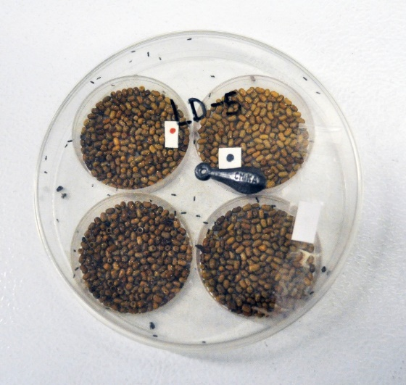

**Figure S2**. **Experimental microcosm containing moth beans, cowpea weevils, and *A. calandrae* parasitoids**.

**Manipulation of the Vulnerable Host Stage**.

Replicate microcosms were subjected to the following four treatments: (1) high variance in the duration of the *H*2 stage, (2) normal variance in the duration of the *H*2 stage, (3) an experimental control, and (4) an unmanipulated control. For the first three treatments, *H*1 was fixed at 9-12 days (median of 10.5 d), less than the minimum duration of the *H*1 stage (Table S1). Experimental manipulation of the *H*2 stage involved replacing beans infested with weevils near the end of the invulnerable juvenile stage (i.e., the 4 dot stage) with beans containing weevils that have been in the *H*2 stage for different lengths of time. A diagram of their effects on the mean development time of each stage is shown in Figure S3.

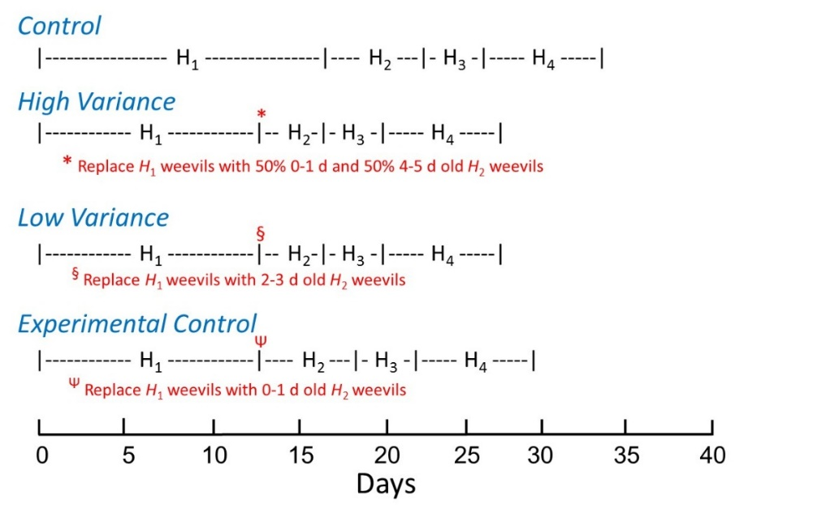

**Figure S3.** **Diagram of the experimental treatment and its effect on the average development times of the weevil life stages.**

Owing to the one-time pulse addition of weevils and parasitoids, the distribution of life stages was initially very discrete. We therefore waited seven months for the host and weevil populations to achieve a more continuous distribution of life stages and for any transient dynamics to abate before beginning the experimental manipulations.

**Testing Assumptions of Experimental Approach**

Our bean replacement procedure and accounting of host age relies on three important assumptions. First, egg-to-window survivorship must be high so that the presence of an egg (or eggs) on a bean is a strong indicator that the bean will support a weevil that reaches the *H*2 stage. Second, regardless of the number of weevil eggs laid on a moth bean, only one weevil will mature to the *H*2 stage. Third, for the first egg(s) laid on a bean (and consequently marked with a single dot), an egg from that cohort must be the one to survive to the *H*2 stage. In other words, intraspecific competition within the bean is ruled by priority effects. If these latter two assumptions are not true, then it would be impossible to know the age of weevils in the *H*1 stage.

To test the validity of the first two assumptions, we exposed 20 g of moth beans to a large number of weevils (≈ 75-100) and allowed the females to oviposit for 24 h (in a growth chamber at 28 ± 2 C, 50 ± 5% RH and 12:12 day: night light cycle). Five days later, these beans were inspected for the presence of white eggs (an indicator of a fertilized and viable egg). We then divided beans into groups according to the number of white eggs per bean (1, 2, .., 6 eggs; 6 eggs being the maximum number found per bean). Starting 9 days post egg-laying, beans were inspected daily for the appearance of an emergence window (i.e., the start of the *H*2 stage). If a window was evident, the bean was dissected to confirm that there was a live host, and to determine whether more than one live weevil was present in the bean. A total of 392 egg-infested beans were included in this study (*n*1=169, *n*2=85, *n*3=61, *n*4=33, *n*5=30, *n*6=14; where the subscript represents the egg number per bean).

For all egg-infested beans combined, the probability that a weevil survived to the *H*2 stage was 95.7%. Based on a chi-square test for independence, the probability of survival did not differ significantly between the different egg-number categories (χ2 = 0.945, *df* = 4, *P* = 0.92; highest two egg categories combined). Based on our dissections, if a window was present, the bean contained one alive late-instar larva or early-stage pupa. In zero instances was more than one living weevil present in the bean. Three additional repetitions of this experiment were conducted, although beans were not dissected and we recorded only the probability of a window being present on the bean. The results were the same – among the three repetitions, the probability of that a weevil survived to the *H*2 stage was 0.97 ± 0.01. Overall, these results provide strong support for assumption one that egg-to-window survivorship is very high and assumption two that regardless of the number of eggs laid per bean, only one weevil will mature to the *H*2 stage.

To test the third assumption, that earlier hatchlings outcompete later hatchlings, we conducted the following experiment. One 55 mm petri dish containing 25 g of moth beans were exposed to 20 weevils for 8 h. After 3 days, beans were inspected and all those that had only one white egg attached were retained (*n* = 186 beans). Using a fine permanent marker, we placed a small dot immediately adjacent to the egg to denote the first egg laid on the bean. All other beans were discarded. We then divided the beans with one egg into three groups – those that would be subjected to subsequent weevil oviposition at 3 days (comparable to a situation in the experimental microcosms where new eggs would be laid on previously infested beans in the next census; i.e., when the beans were marked with two-dots), six days (when beans were marked with 3-dots) and 9 days (when beans reached the final four-dot stage). For each treatment, the beans were placed together in a petri dish, and at the appropriate time, 20 mated female weevils were added for 8 hours. At the end of the exposure period, beans were inspected for new eggs. If more than 1 new egg was present, all supernumerary eggs were scraped off with an insect pin. After incubating the beans for three days, if the new eggs did not turn white, the bean was discarded. This procedure resulted in 42 beans for the treatment in which there was a 3-day lag between the first and second egg laid (“3-day treatment”), 35 beans for the treatment with a 6-day lag (“6-day treatment”) and 28 beans for the treatment with a 9-day lag (“9-day treatment”) between the first and last egg laid.

For the 6- and 9-day treatments, we dissected the beans 14 days after the first egg was laid. This is the minimum time interval for weevils to mature to the *H*2 stage (see Table S1). At this time, the difference in size between a juvenile from the first and second egg was obvious. The juvenile from the first egg was at its maximal size by this time, whereas the larva from the second egg was substantially smaller, especially for the 9-day treatment. In only two instances (the 9-day treatment) did we find an early-mid instar weevil in the bean that would suggest the larva from the second egg laid was the survivor. However, based upon a careful dissection of the beans, we found that the larva from the first egg laid died soon after hatching, as evidenced by short, narrow feeding tunnels.

Because the weevil juveniles in the 3-day treatment were separated by such a short time period, we were concerned that differentiating between them based on size might be problematic if we waited until day 14 (as for the above treatments). Therefore, we adopted a slightly different approach to investigating the fate of these weevils. We divided the beans into two equal groups (n = 21 per group) and dissected one group at 8 days, and the second group at 11 d. During our dissections, we followed the feeding tunnels of both weevils to determine their fates. For beans dissected at day 8, all 21 weevils from the first egg were alive, whereas 18 of the weevils from the second egg were alive. In the three cases where the second weevil was dead, the egg was laid close to the first weevil and their feeding tunnels quickly intersected. Judging by the size of the survivor, it was the weevil from the first egg that was still alive (at this time the weevil from the second egg is a tiny first instar).

For beans in the 3-day treatment that were dissected at 11 days, we found only four beans out of 21 with two live larva (19%). These larvae were on opposite sides of the bean and the larger of the two had consumed about two-thirds of the bean and was about twice the size of the smaller weevil. The large weevil was at the side of the bean where the first egg was laid and the smaller weevil was in close proximity to the second egg laid. Given that only one weevil ever survives to adult eclosion, we expect that one of those two weevils would have died, most likely the smaller one through direct interference or scramble competition (Toquenaga 1993; Guedes *et al.* 2007). For those beans with only one larva, the larvae were of the larger size, and in 11 cases it was clear that they traced back to the position of the first egg laid. In the remaining 6 cases, the origin was ambiguous, but their size strongly suggested they derived from the first egg laid.

Overall, our data strongly support the importance of priority in determining the outcome of competition. With a long time lag between the first and second eggs laid (6 or 9 days), the weevil from the first egg laid was always the victor. Even with a short lag of 3 day, our data strongly suggest that most, if not all, of the survivors were from the first egg. Consequently, our third assumption is deemed correct.

**Parasitoid Functional Response**

A key component of our model formulation is the functional response model, because it can have both stabilizing and destabilizing effects on host-parasitoid population dynamics. We conducted an experiment in which various densities of vulnerable hosts were exposed to different densities of parasitoids, and for different times (chosen to mimic exposure durations in our experiments). We then recorded the per-capita number of hosts parasitized in each treatment. A summary of these results are presented in Figure S4.

A simple but flexible model of parasitoid behavior was then fitted to the data that incorporated a Type II functional response as well as a negative binomial distribution of attacks among hosts (Hassell 1980, 2000). The model was of the form *xa* = 1 – [1+*αPT/*(*k*(1*+αthN*))]-*k*, where *xa* is the fraction parasitized, *P* and *N* are parasitoid and host density, *α* is the search rate of the parasitoid, *T* is the time vulnerable hosts and parasitoids were interacting, while *th* is handling time. The parameter *k* indexes the amount of parasitoid aggregation, and can also be viewed as a measure of density-dependence in parasitoid search (smaller *k* indicates more density-dependence). This model provided a good fit to the functional response data (*R*2 = 0.86) and indicated that handling time *t­­h* was negligible (its 95% confidence interval overlapped zero), implying the functional response was essentially Type I. There was also a significant amount of density-dependence in parasitoid search (*k* = 0.839, 95% confidence interval: [0.220, 1.459]). This result helps justify our use of negative binomial parasitoid search in our modeling work.

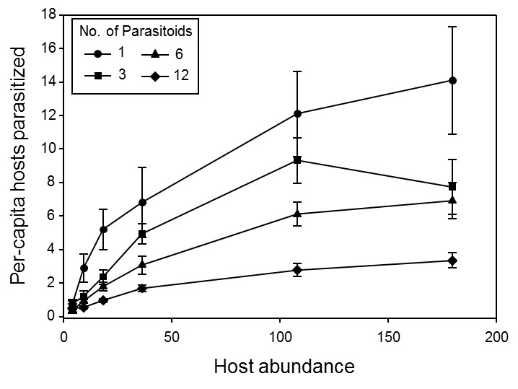

**Figure S4. Functional response of *A. calandrae* to different densities of its host *C. maculatus*. Each curve represents the mean ± se per-capita number of hosts parasitized (n = 10 per host abundance category) for microcosm containing 1, 3, 6 or 12 female parasitoids. Foraging period was 3 d.**

**Time-Series Analyses**

For the analyses of the time-series data, we omitted the first four census dates (post experimental manipulation) to reduce the effects of transient dynamics on the system. Time-series data for number of live hosts and parasitoids in each microcosm are reported in Figure S5. From these time-series data, we computed for each microcosm, the mean and standard deviation (sd) of log10 (*N*+1) transformed host and parasitoid abundances among census dates (where *N* is the number of adults). Differences in the mean abundance or sd in abundance among treatments (High-variance, Normal-variance, Unmanipulated control) were assessed using separate Welch’s ANOVAs (Welch 1951). A Welch’s ANOVA accounts for heterogeneity of variances among treatments by weighting the means by the reciprocal of the group mean variances. Treatment was a fixed factor in the model and the microcosm was the unit of replication. Differences among treatment pairs were also assessed using a Welch’s ANOVA and a Bonferroni-corrected level of α was used to maintain an overall Type I error rate among the tests at 0.05.

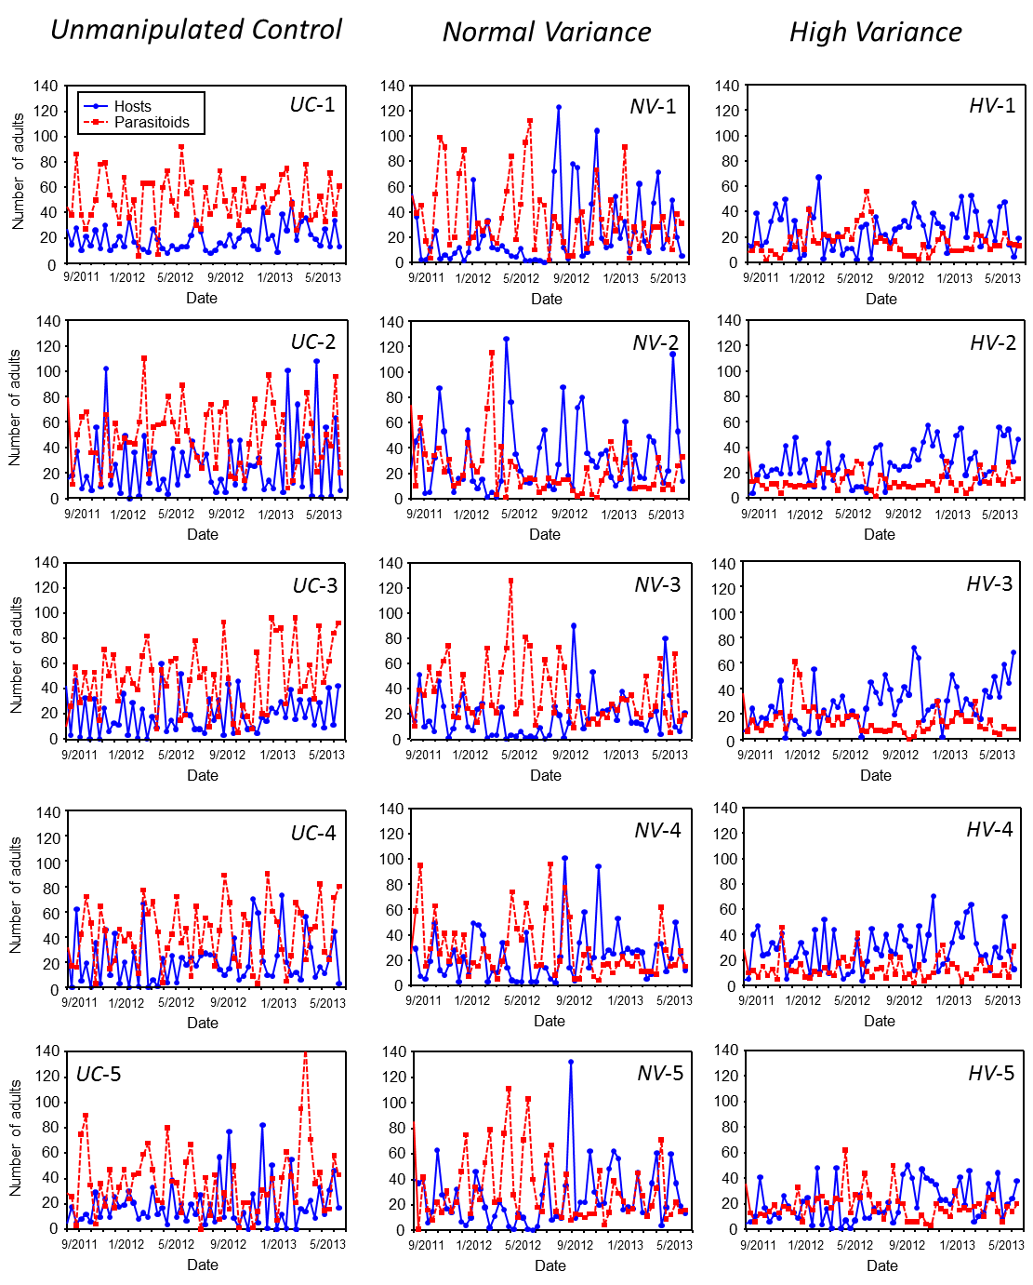

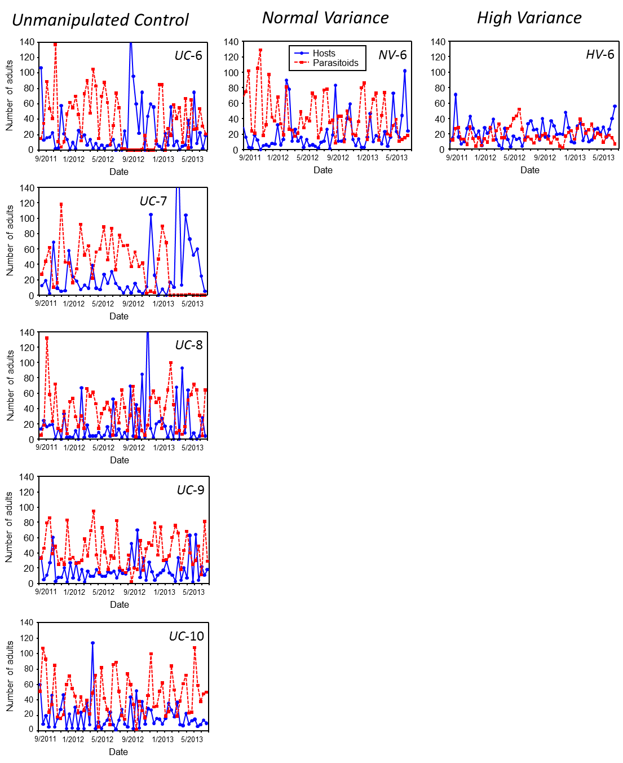

**Figure S5.** **Time series for the host and parasitoid for all unmanipulated control, Normal-variance and High-variance microcosms.** Abundances are for live adults only and were obtained every 12 d. Raw data for each time series have been deposited in the NERC Centre for Population Biology, Imperial College, The Global Population Dynamics Database (http://www.sw.ic.ac.uk/cpb/cpb/gpdd.html).

We used wavelet analyses to explore the cyclical behavior of host and parasitoid population dynamics in each experimental microcosm. Wavelet analysis, like a Fourier analysis, is used to decompose a signal (or time series) into its different oscillatory components with different frequencies (periods) (Torrence & Compo 1998; Cazelles *et al.* 2008). However, unlike a Fourier analysis, the wavelet analysis can be applied to time series where the frequency and amplitude of oscillations vary through time. Given that many time series exhibit nonstationarity (Cazelles *et al.* 2008) the ability to evaluate the spectral characteristics of a time series as a function of time, is a desirable attribute of this method.

The wavelet transform, which measures the cross correlation between a wavelet function and the time series data, is computed as the integral of the amount of overlap as the wavelet function travels across the time series. The power of signals of different period length in the time series data was determined as the square of the wavelet transforms. In a departure from standard practice, we did not normalize the power spectra by the variance of the time series, because we wanted to compare the absolute amount of power at different periods across treatments. The wavelet transform and wavelet power spectrums were computed for the host and parasitoid populations from each of the replicate microcosms using the package *Biwavelet* in R 3.0.2 and are reported in Figure S6.

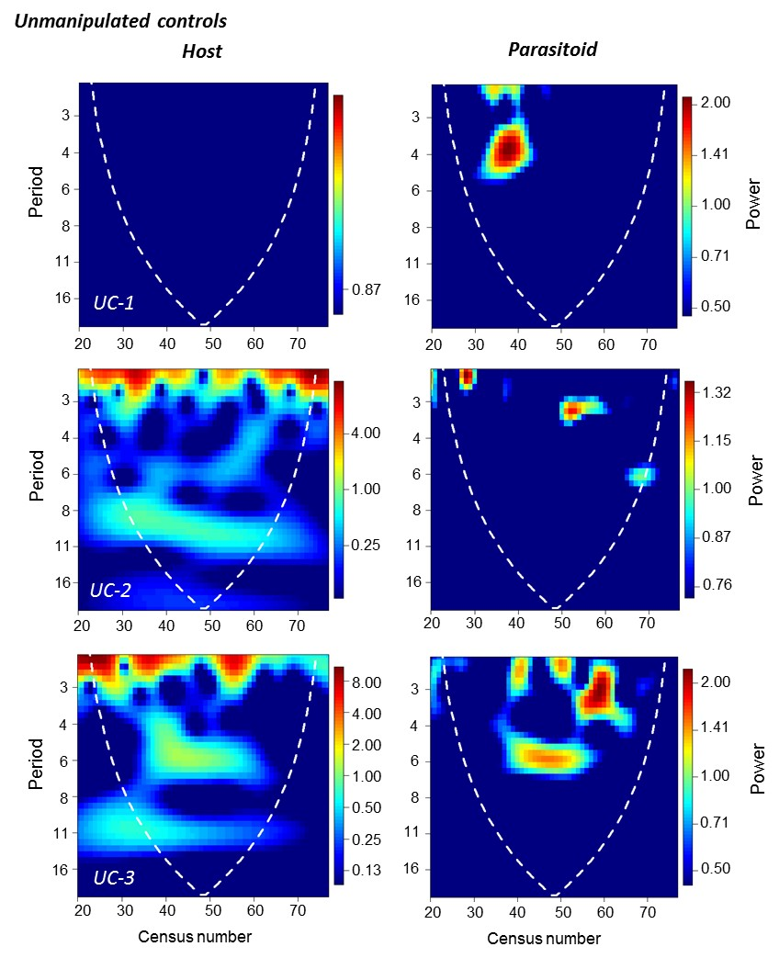

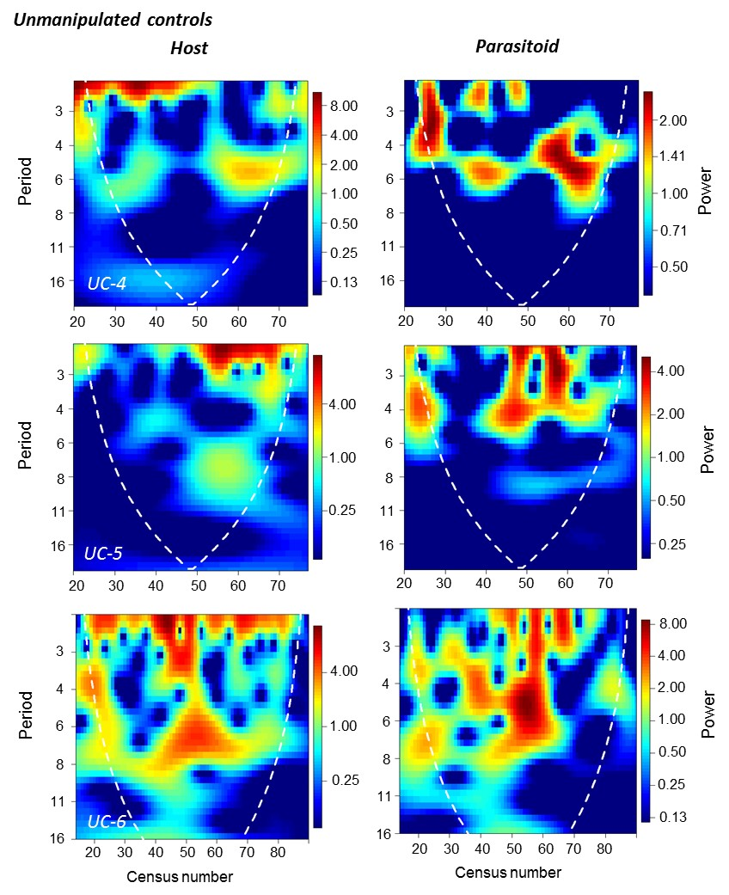

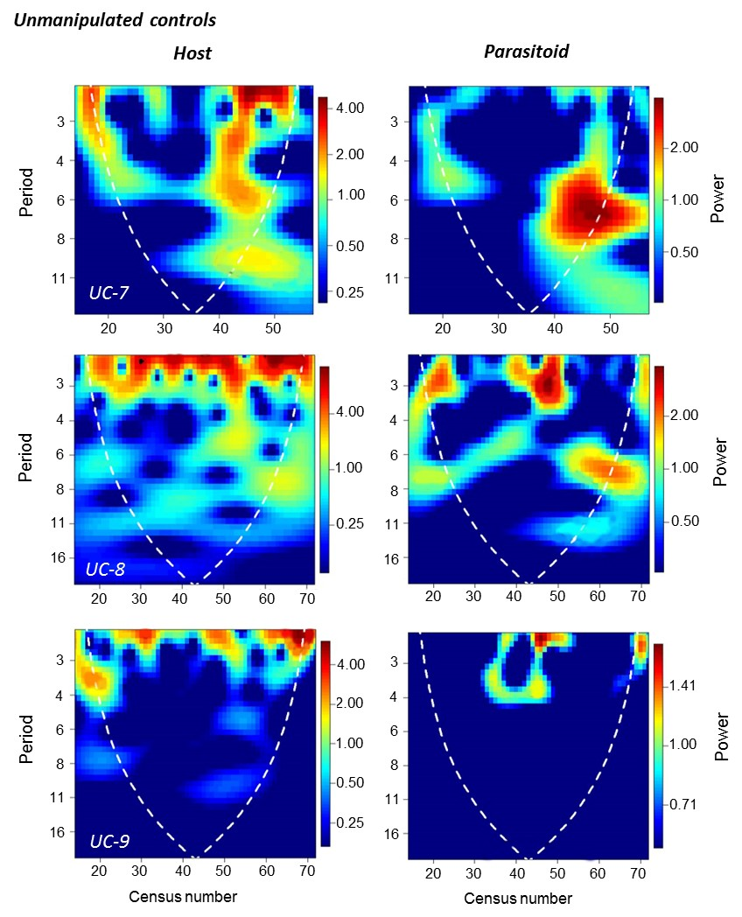

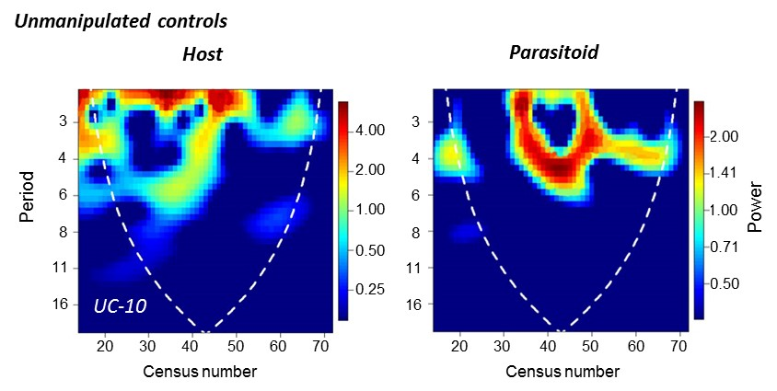

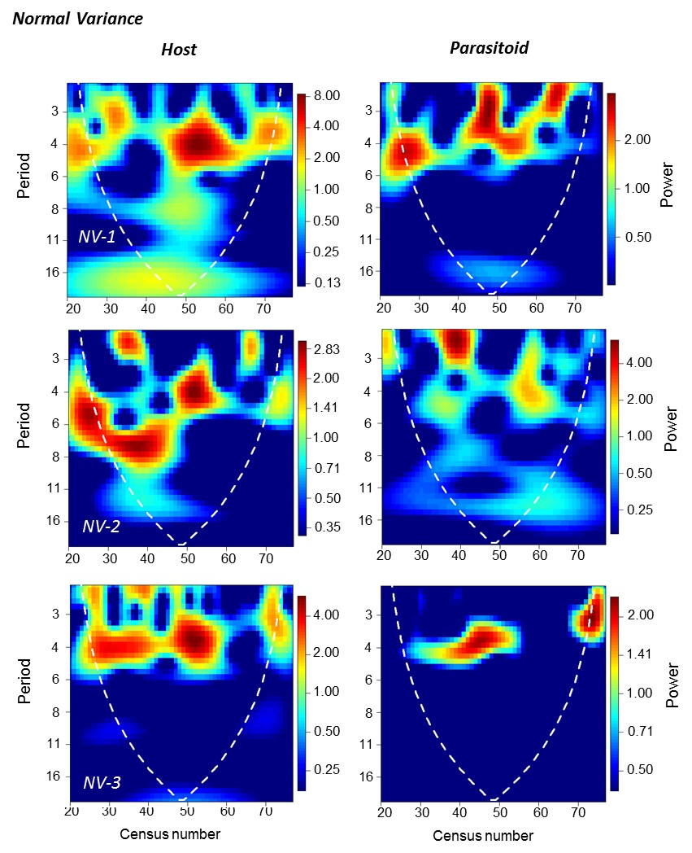

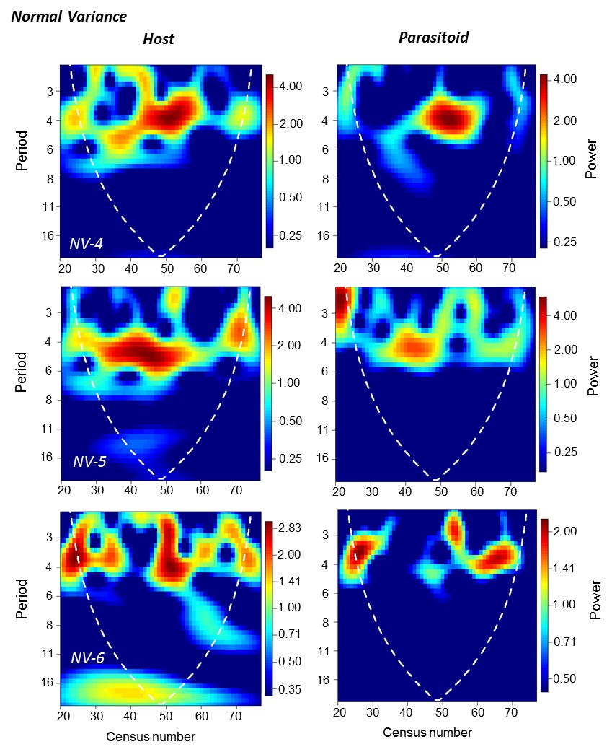

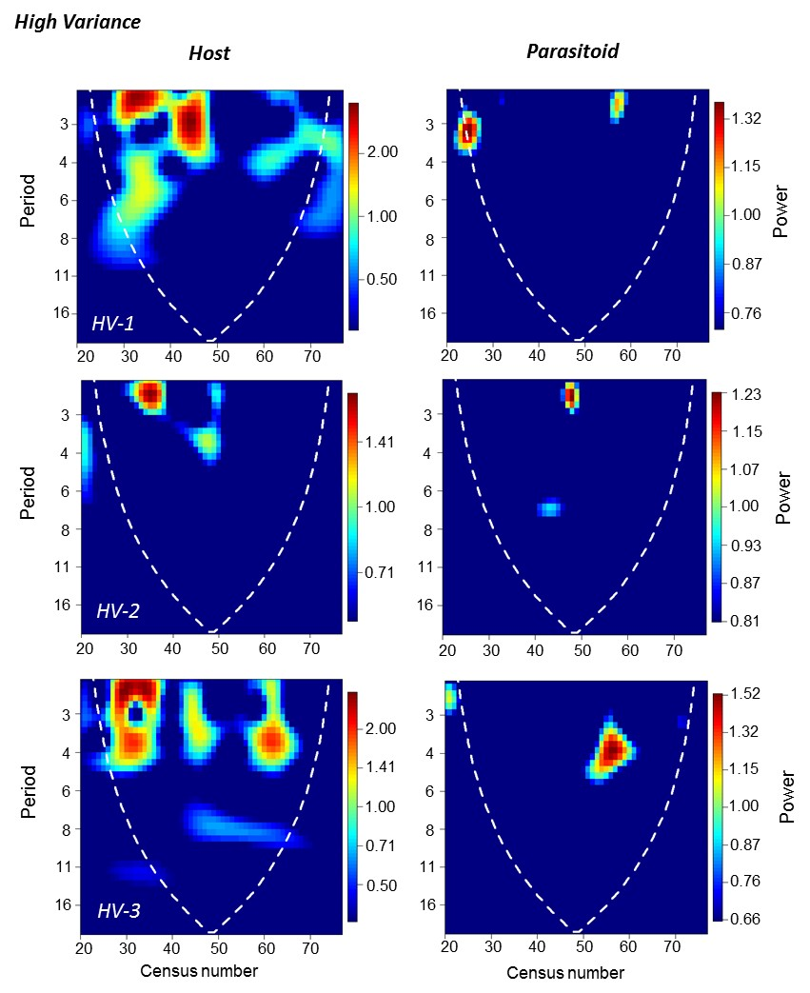

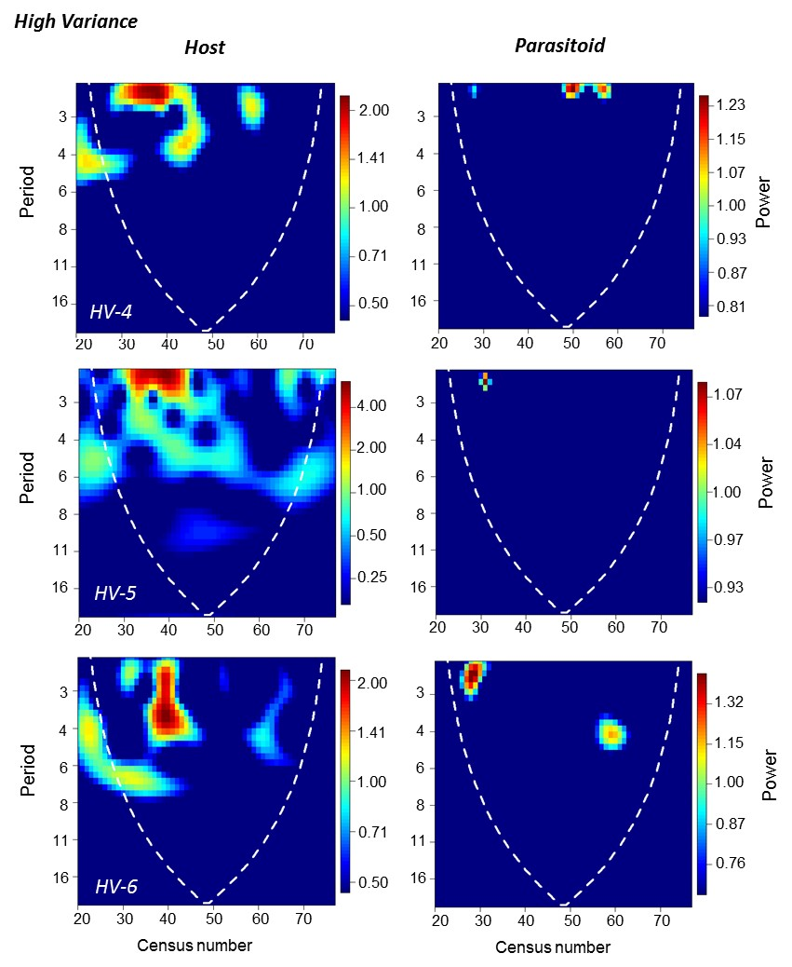

**Figure S6.** **Wavelet power spectrums for the host and parasitoid for all Unmanipulated control, Normal-variance and High-variance microcosms.** The white dashed lines are the cones of influence which indicate where edge effects may influence results.

Because the wavelet analyses revealed no clear evidence of nonstationarity in the time series for each treatment (Figure S6), we averaged the wavelet power values for each period across the entire time series. This yielded a global wavelet spectrum (comparable to a Fourier power spectrum) that identifies the relative oscillatory strength for each possible period. Global wavelet spectrums for the host and parasitoid population for every microcosms are reported in Figure S7. For comparisons among treatments, we computed the mean and 95% CIs of the global wavelet spectrum for all replicates within treatment.

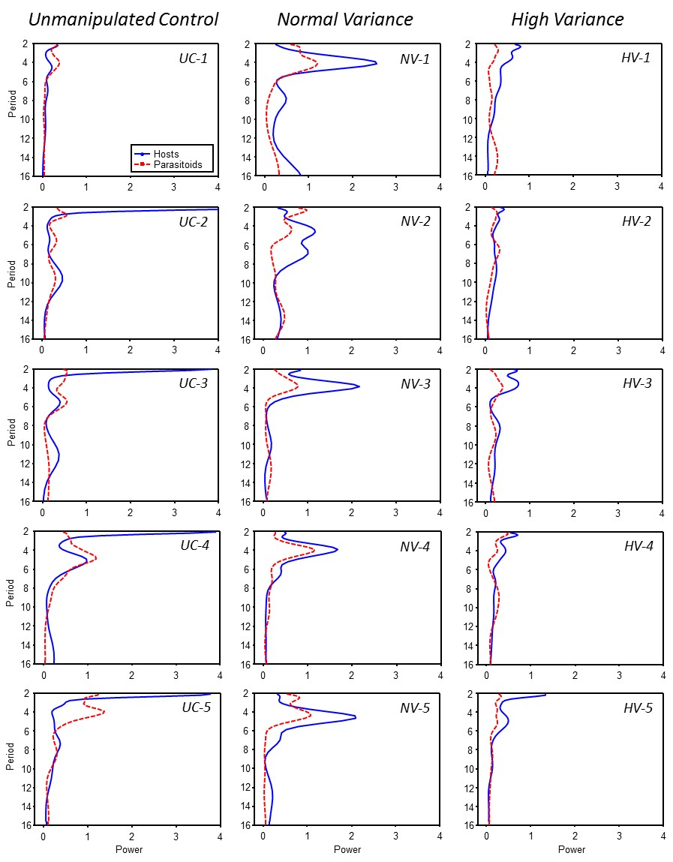

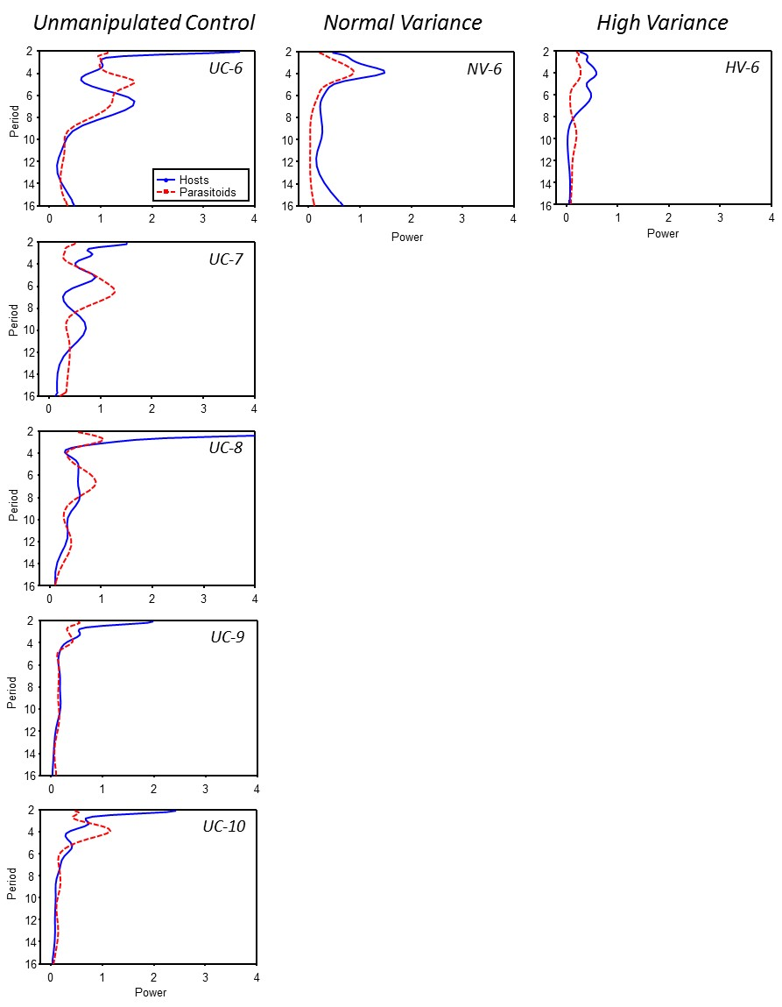

**Figure S7.** **Global wavelet spectrums (wavelet power per period averaged across the entire time series) for the host and parasitoid for all unmanipulated control, Normal-variance and High-variance microcosms.**

**The Host-Parasitoid Model**

**Basic Model Structure**

The basic model structure and assumptions of simple versions of the model have been discussed in Murdoch et al. (Murdoch *et al.* 1987) and Godfray and Hassell (Godfray & Hassell 1989), and the assumptions of gamma distributed maturation times were discussed in Wearing et al. (Wearing *et al.* 2004) and Xu et al. (Xu *et al.* 2010). This model is an extension of the Xu et al. (Xu *et al.* 2010) models.

Here we assume that maturation of hosts in stages *H*1, *H*2, *H*4 and parasitoids in *P*1 stage (see Table S1 for their definitions) follow gamma distributions with a certain minimal development time. Let $H_{1}^{i}$ be the number of hosts in *H*1 stage in the *ith* petri dish, *i=1, 2, 3, 4* (recall each microcosm contains 4 small petri dishes). Then $H_{1}^{i}$ can be expressed as

$H_{1}^{i}=\int_{0}^{t}{R^{i}\left(s\right)prob(t-s)e^{-μ_{H_{1}}(t-s)}}ds$, (1)

where $R^{i}\left(t\right)$ denotes the recruitment rate of valid eggs at time *t*, while $prob\left(s\right)$ is the probability with which hosts stay in *H*1 stage for *s* long time, equal to $1$ for $s<τ_{H_{1}}$, and $\tilde{G}(s-τ_{H_{1}})$ for $s≥τ_{H_{1}}$. Assume that the maturation of hosts into the next stage *H*2 follows a gamma distribution with rate parameter $C_{H_{1}}$ and shape parameter $m_{H_{1}}$, i.e.,

$$g\left(s,C_{H_{1}},m_{H_{1}}\right)=\frac{{C_{H_{1}}}^{m_{H_{1}}} s^{m_{H_{1}}-1}}{m_{H_{1}}!}e^{-C_{H_{1}}s}.$$

Denoting its cumulative distribution function by $G(s)$, then $\tilde{G}\left(s-τ_{H_{1}}\right)=1-G(s-τ_{H_{1}})$. Using the linear chain trick (MacDonald 1978), we can reduce the integral equation (1) into the following differential equations

$$H_{1}^{i}=\sum_{j=0}^{m_{H_{1}}}{H_{1}^{i, j}},$$

$$\frac{dH_{1}^{i, 0}}{dt}={R^{i}\left(t\right)- R^{i}\left(t-τ_{H_{1}}\right)e^{-μ_{H_{1}}τ_{H_{1}}}-μ_{H_{1}}H}_{1}^{i, 0},$$

$\frac{dH_{1}^{i, 1}}{dt}={ R^{i}\left(t-τ_{H_{1}}\right)e^{-μ_{H_{1}}τ_{H_{1}}}-(C_{H_{1}}+μ_{H_{1}})H}_{1}^{i, 1},$ (2)

$$\frac{dH_{1}^{i, j}}{dt}={C_{H_{1}}H_{1}^{i, j-1} -(C_{H_{1}}+μ_{H_{1}})H}_{1}^{i, j}, j=2, 3,⋯, m_{H_{1}}.$$

Essentially, this reduction means that the stage *H*1 is divided into $m_{H_{1}}+1$ substages and the term $C_{H_{1}}H_{1}^{i, m_{H_{1}}}$ represents the rate of hosts entering *H*2 stage. Using a similar approach, we can obtain the equations for the number of hosts in *H*2 stage:

(3)

$\frac{dH_{2}^{i, j}}{dt}={C_{H_{2}}H_{2}^{i, j-1} -(C_{H_{2}}+f\left(P_{2}\right)+μ_{H_{2}})H}_{2}^{i, j}, j=2, 3,⋯, m_{H_{2}}.$

Here the attack rate by adult parasitoids $P_{2}$ is modeled by $f\left(P_{2}\right)=k\ln{(1+a P_{2}/k)}$, describing density dependence acting on parasitoid search. The term $C_{H_{2}}H_{2}^{i, m_{H_{2}}}$ provides input into the *H*3 stage. Assuming that hosts stay in the *H*3 stage for a fixed time $τ_{H_{3}}$ and then enter into the adult stage *H*4, we then have the equations for the number $H_{4}$ of adult hosts:

$H_{4}=\sum_{j=0}^{m_{H_{4}}}{H_{4}^{j}}, A\left(t\right)=\sum_{i=1}^{4}{C_{H_{2}}H_{2}^{i,m_{H_{2}}}\left(t\right)},$

$\frac{dH_{4}^{0}}{dt}={A\left(t-τ_{H_{3}}\right)e^{- μ_{H_{3}} τ_{H_{3}}}-A\left(t-τ_{H_{3}}-τ_{H_{4}}\right)e^{- μ_{H_{3}} τ_{H_{3}}-μ_{H_{4}} τ_{H_{4}}} –μ_{H_{4}}H}_{4}^{0},$

$\frac{dH_{4}^{1}}{dt}={A\left(t-τ_{H_{3}}-τ_{H_{4}}\right) e^{- μ_{H_{3}} τ_{H_{3}}-μ_{H_{4}} τ_{H_{4}}}-(C_{H_{4}}+μ_{H_{4}})H}_{4}^{1},$ (4)

$$\frac{dH_{4}^{j}}{dt}={C_{H_{4}}H_{4}^{j-1} -(C_{H_{4}}+μ_{H_{4}})H}_{4}^{j}, j=2, 3,⋯, m_{H_{4}}.$$

The terms $f\left(P_{2}\right)H_{2}^{i, j}$ in (3) are newborn parasitoids and the number $P_{1}^{i}$ of juvenile parasitoids in dish *i* is similarly governed by the following equations:

$P_{1}^{i}=\sum_{j=0}^{m_{P_{1}}}{P_{1}^{i, j}},$

$\frac{dP_{1}^{i, 0}}{dt}=f\left(P_{2}\right)H_{2}^{i}- f\left(P_{2}(t-τ_{P_{1}})\right)H_{2}^{i}{\left(t-τ_{P_{1}}\right)e^{- μ_{P_{1}} τ_{P_{1}}} –μ_{P_{1}}P}_{1}^{i, 0},$

$\frac{dP_{1}^{i, 1}}{dt}=f\left(P_{2}(t-τ_{P_{1}})\right)H_{2}^{i}\left(t-τ_{P_{1}}\right)e^{- μ_{P_{1}} τ_{P_{1}}}-(C_{P_{1}}+μ_{P_{1}}) P_{1}^{i, 1}$ (5)

$$\frac{dP_{1}^{i, j}}{dt}={C_{P_{1}}P_{1}^{i, j-1} -(C_{P_{1}}+μ_{P_{1}})P}_{1}^{i, j}, j=2, 3,⋯,m_{P_{1}}.$$

Our lab studies (Table S1) show that the survivorship curve of adult parasitoids is not close to a gamma or exponential distribution curve. Therefore, we divide the adult stage *P*2 into three substages, each of them having a fixed time period, and an exponential survivorship. Hence the number of adult parasitoids can be modeled as

$P_{2}=\sum_{j=1}^{3}{P_{2, j}^{ }}, A_{P}=\sum_{i=1}^{4}{C_{P_{1}}P_{1}^{i, m_{P_{1}}}},$

$\frac{dP_{2,1}}{dt}=A_{P}- A_{P}\left(t-τ_{1}\right)e^{-μ_{1} τ_{1}}- μ_{1}P_{2,1} ,$

$\frac{dP_{2,2}}{dt}=A_{P}\left(t-τ_{1}\right)e^{-μ_{1} τ_{1}}- A_{P}\left(t-τ_{1}-τ_{2}\right)e^{-μ_{1} τ_{1}-μ_{2} τ_{2}}- μ_{2}P_{2,2} ,$ (6)

$\frac{dP_{2,3}}{dt}=A_{P}\left(t-τ_{1}-τ_{2}\right)e^{-μ_{1} τ_{1}-μ_{2} τ_{2}}- A_{P}\left(t-τ_{1}-τ_{2}-τ_{3}\right)e^{-μ_{1} τ_{1}-μ_{2} τ_{2}-μ_{3} τ_{3}}- μ_{3}P_{2,3} .$

To complete the model we need to describe the recruitment rate of eggs in each dish, which depends on the number of fresh and unoccupied beans in a microcosm. Across a wide range of adult weevil densities in laboratory microcosms, females *Callosobruchus* distribute eggs approximately evenly among beans (Avidov *et al.* 1965; Messina & Renwick 1985; Mbata 1992). Also, regardless of the number of eggs laid per bean, at most, only one adult weevil can emerge per bean; invariably, the first egg laid is the one to survive (see section “Manipulation of the vulnerable host stage”). Here, we assume that the egg first laid on a bean is the winner of intraspecific competition and has the potential to develop into an adult. *H*4 adults are also assumed to lay healthy eggs at the rate $\frac{θ_{1}H_{4}}{{(1+θ_{2} H_{4})}^{b}}$ which describes the density-dependence in the system. We then can model the number of beans that are available for new healthy eggs and the recruitment rate of eggs in dish *i* as follows

$$R^{i}=\text{min}\left(B^{i}, \frac{θ_{1}H_{4}}{{\left(1+θ_{2} H_{4}\right)}^{b}} \frac{B^{i}}{\sum_{i=1}^{4}{B^{i}}}\right),$$

$\frac{dB^{i}}{dt}=-R^{i}, i=1, 2, 3, 4.$ (7)

Because the ratio of females to males is one to one under the temperature and humidity conditions of this experiment (Stillwell & Fox 2007), we can model only the numbers of females. Therefore, we require that $\frac{dB^{i}}{dt}$ equal to zero whenever $B^{i}$ is less than 0.5. Because every 12 days a new petri dish with fresh beans replaces the oldest dish (48 days at the time of replacement) in the microcosm, we need to include pulses of beans into (7), that is, the beans $B^{i}$ corresponding to the new dish has to equal to the number $B_{0}$ of fresh beans added to the microcosm on census days. At the same time, the variables $B^{i}$, $H_{1}^{i, j}$, $H_{2}^{i, j}$ and $P_{1}^{i, j}$ corresponding to the oldest dish are set to be zero. The equations (2) – (7) with the above requirements form our model. A summary of the model parameters and their definitions is provided in Table S2.

**Table S2**. **A description of the parameters used in the host-parasitoid model, how we obtained estimates of them (Source), and the range of values used in the models (Estimate).** **Source includes references to specific sections or figures in the appendix.**

|  |  |  |  |
| --- | --- | --- | --- |
| **Model parameters** | **Definition** | **Source** | **Estimate** |
| $$θ_{1}$$ | Number of healthy eggs laid by a female host | “Development Times and Fecundities” | [7, 16] |
| $$θ_{2}$$ | Host density dependence | Estimated from model fit to Host-only microcosms, “The Model Simulation”, Figure S7 | [0.03, 0.06] |
| *b* | Intensity of host density dependence | Estimated from model fit to Host-only microcosms, “The Model Simulation”, Figure S8 | [0.6, 1.2] |
| $τ_{H_{i}}$, $τ_{P_{1}}$ | Minimum time period of hosts in stage *i, i*=1, 2, 3, 4, and immature parasitoids *P1* | “Development Times and Fecundities” | $τ_{H_{1}}$: [11, 15]; $τ_{H_{2}}$ : [0.7, 1.5]; $τ_{H_{3}}$ : [1.7, 3]; $τ_{H_{4}}$ : [0.8, 1.5]; $τ_{P_{1}}$ : [9, 12] |
| $$τ_{i}$$ | Time periods of adult parasitoids in substage *i*, *i*=1, 2, 3 | “Development Times and Fecundities” | $τ_{1}$: [1.2, 2.2]; $τ_{2}$ : [1.5, 4]; $τ_{3}$ : [2, 4.5]; |
| $$C_{H_{i}}$$ | Rate parameter of gamma distribution of hosts in stage *i*, *i=*1, 2, 4 | “Development Times and Fecundities” | *H*1: [2, 4]  *H*2: [13.2, 17.8]  *H*4: [3, 5.5] |
|  | Shape parameter of gamma distribution of hosts in stage *i*, *i=*1, 2, 4 | “Development Times and Fecundities” | *H*1: [4, 8]  *H*2: [60, 76]  *H*4: [13, 22] |
|  | Rate parameter of gamma distribution of juvenile parasitoids | “Development Times and Fecundities” | [10.5, 20] |
| $$m_{P_{1}}$$ | Shape parameter of gamma distribution of juvenile parasitoids | “Development Times and Fecundities” | [65, 77] |
| $$μ_{H_{i}}$$ | Natural death rate of hosts, *i=*1, 2, 3, 4 | “Development Times and Fecundities”, “Testing Assumptions of Experimental Approach” and dissections, and roughly estimated from dissection of beans | Fixed at 0.001 |
| $μ_{P_{1}}$, $μ_{i}$ | Natural death rates of juvenile *P*1 and adult parasitoids, *i=*1, 2, 3 | “Development Times and Fecundities”, roughly estimated from bean dissections | $μ_{P_{1}}$ =0.01, fixed $μ_{1}$ : [0.04, 0.1]; $μ_{2}$ : [0.2, 0.32] $μ_{3}$ : [0.05, 0.12] |
| *k* | Clumping parameter for the negative binomial model of parasitism | “Parasitoid Functional Response”, Figure S4 | [0.25, 1.2] |
| *a* | Parasitoid attack rate | “Parasitoid Functional Response” | [0.02, 0.1] |
| *B0* | Number of fresh beans on census days | Lab counts of moth beans added each census date | [50, 80] |

**The Model Simulation**

Our models contain a large number of parameters for which some prior information is available (Table S1, (Utida 1941; Utida 1957; Fujii 1983; Toquenaga & Fujii 1990; Ji *et al.* 2004; Tuda & Shimada 2005)), but under conditions that could potentially differ from the microcosms. To obtain parameter estimates tailored to the microcosms, we first chose small ranges over which the parameters may vary based on this prior information. We then chose parameter values for the simulations using the method of Latin hypercube sampling (Stein 1987). Parameters were sampled using a uniform probability distribution across the specified ranges. We then simulated the model using these parameter values and compared the model dynamics with the microcosm time series.

We began by fitting our model to adult weevil dynamics. We established three replicate experimental microcosms where only newly eclosed adult hosts were added. The numbers of adult hosts were counted every day for the first 49 days of the experiment (spanning approximately two adult weevil generations). These replicates were otherwise similar to the host-parasitoid microcosms used in the main study. We assessed the fit of the model for a particular set of parameter values using root mean square error. The best-fitting trajectories matched the parameter values quite well (Figure S8).

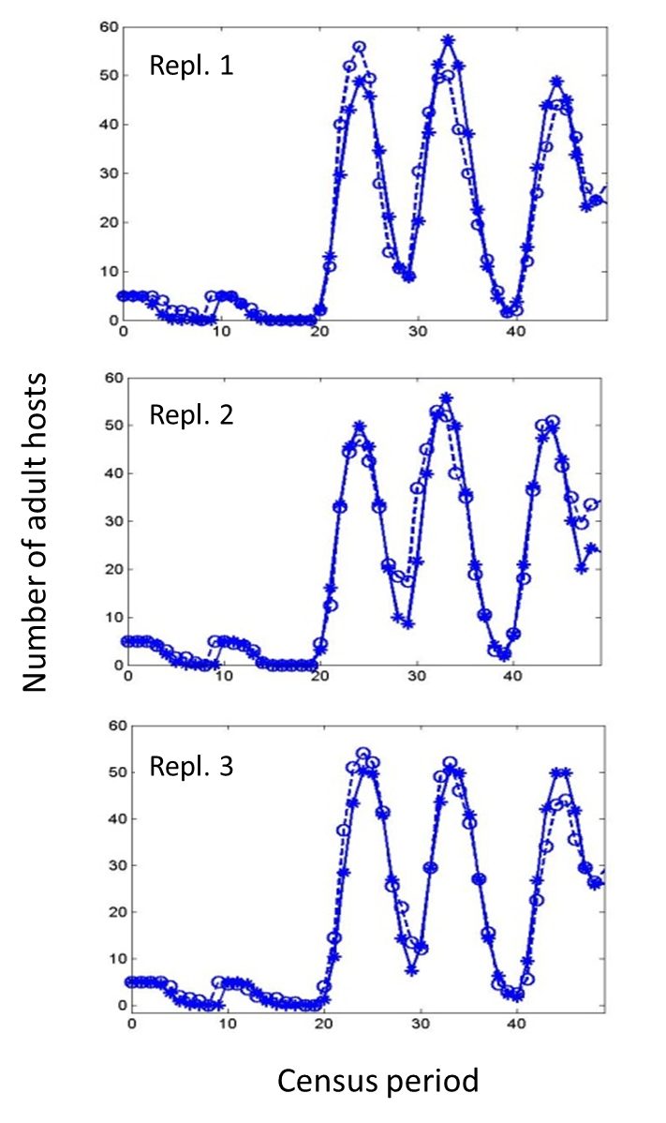

**Figure S8.** **Numbers of adult hosts versus day. The best model trajectories matched with host-only time sequence data. Dashed lines with open circles represent actual daily adult host counts in laboratory microcosms while solid lines with stars are model trajectories.**

Using the parameter estimates for the host-only microcosms as a starting point, we then sampled both host and parasitoid parameters and solved the model for each parameter set, assuming the control treatment was in effect. We were unable to use trajectory matching for the host-parasitoid data, because these time series were much longer, and one would expect the models and data to diverge over time because of stochasticity in the real system. Instead, we compared the behavior of the simulations with the control microcosms using various time series probes (Kendall *et al.* 1999). For the model simulations, we removed the first 20 observations to reduce transient behavior, log-transformed the data, and then calculated the mean, period 2 wavelet power, and period 4 wavelet power for adult hosts and parasitoids (six total probes). The mean is a basic property of the system, while period 2 and 4 wavelet powers were chosen because these periods were frequently observed in the real system. We then used principal components analysis to summarize the probe results for 912 randomly chosen sets of parameter values. The first three principal components explained 80.3% of the variance in model behavior. The loadings for these components are shown in Table S3. PC1 is primarily a contrast between host probes vs. the parasitoid period 2 power, while PC2 is a contrast between period 4 power in both host and parasitoid vs. host period 2 power. PC3 is mainly a contrast of parasitoid period 2 power vs. the parasitoid mean. Figure S9 and S10 show the model simulations mapped onto principal component space, using the first three components.

**Table S3. Loadings of the first three principal components for time series probes of the host-parasitoid model simulations.** Large values indicate a probe is strongly represented in a component. Differing signs indicate a contrast (tradeoff) in the probe values as one moves along that component axis.

|  |  |  |  |  |  |  |  |
| --- | --- | --- | --- | --- | --- | --- | --- |
|  | **Hosts** | | | **Parasitoids** | | |  |
|  | Mean | Period 2 power | Period 4 power | Mean | Period 2 power | Period 4 power | % Variance explained |
| PC1 | 0.591 | 0.526 | 0.300 | -0.148 | -0.451 | 0.242 | 36.2 |
| PC2 | -0.224 | -0.403 | 0.567 | 0.225 | -0.120 | 0.634 | 23.2 |
| PC3 | 0.121 | -0.137 | -0.225 | 0.775 | -0.519 | -0.215 | 20.9 |

We then mapped the control microcosm data onto the same principal component space. We can use these plots to determine whether the model can generate dynamics similar to the control data, and identify parameter values that best match them. The control data mapped near the cloud of model points along PC1 and PC3 (Figure S9 and S10), suggesting the model was able to capture much of the control dynamics along these axes, but not along PC2, where some points were a considerable distance away. This occurred because a number of the controls had substantial period 4 power relative to the model trajectories, generating large values of PC2. Figure S11 and S12 show one of the control replicates and the model simulation lying closest to that replicate in principal component space. We will use this particular model trajectory (and its parameter values) to understand the dynamics in the various treatments, including the effect of the high variance treatment on stability.

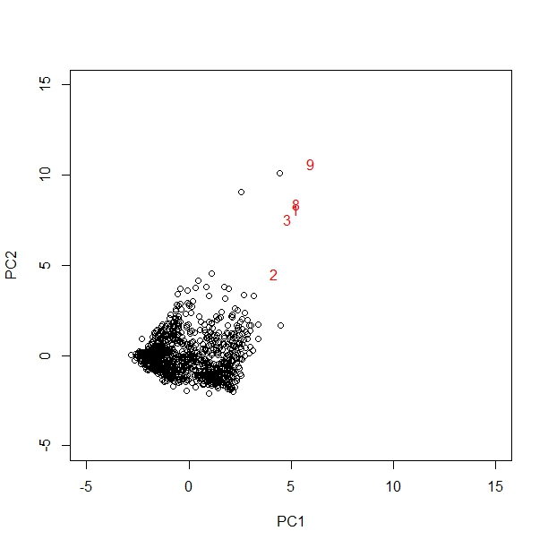

**Figure S9. PC1 and PC2 scores for the host-parasitoid model across 912 randomly chosen parameter sets (○).The unmanipulated control microcosms are shown in red (1 = UC-1, 2 = UC-2, etc.). Several replicates had large positive PC2 values and are not shown. UC-7 was omitted from the analysis because the parasitoid went extinct partway through the study.**

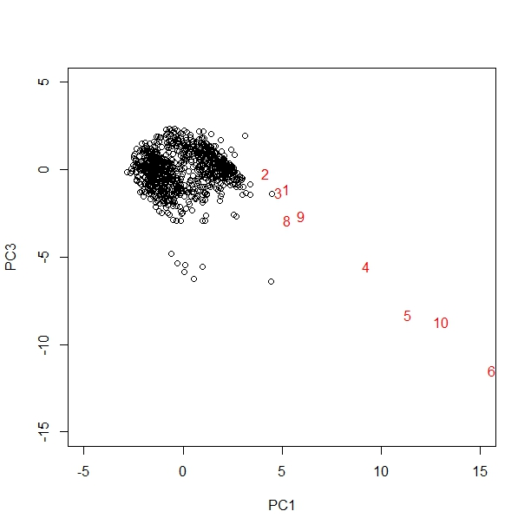

**Figure S10. PC1 and PC3 scores for the host-parasitoid model across 912 randomly chosen parameter sets (○). The unmanipulated control microcosms are shown in red (1 = UC-1, 2 = UC-2, etc.). UC-7 was omitted from the analysis because the parasitoid went extinct partway through the study.**

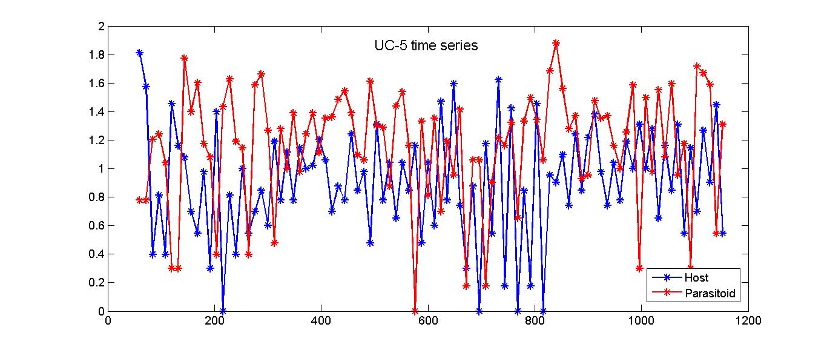

*ln* Abundance of adults

Time (days)

**Figure S11. Time series for unmanipulated (control) microcosm (UC-5): common logarithm of data versus time.**

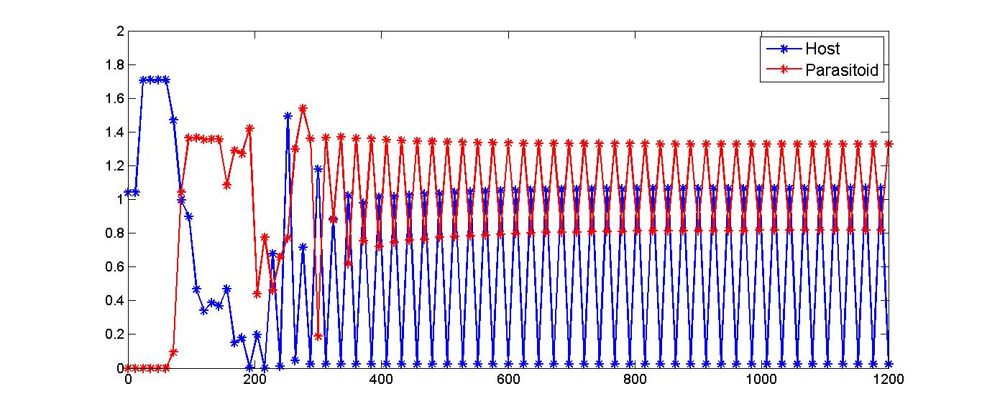

*ln* Abundance of adults

Time (days)

**Figure S12. One model solution lying closest to the unmanipulated control replicate UC-5 (see Figure S11) in principal component space. Time is on the *x*-axis and the common logarithm of solutions on census dates on the *y*-axis.**

**Period 2 Oscillations, Resource Pulses, and Parasitism**

Period 2 oscillations were a common feature of the dynamics in the unmanipulated controls. Our model also produces this pattern, but to understand the mechanism we need to examine its daily behavior between census dates. Here, we use the solution shown in Figure S12 as an example. The daily behavior of this solution is illustrated in Figure S13. The period 2 oscillations arise as follows. Suppose that a dish of fresh beans is placed in the microcosm on the *i*-th census day. If there are sufficient adult hosts (that is, a fair number of *H*2 hosts survive parasitoid attack between the (*i*-1)-th and *i*-th census days), then the eggs produced by the adults will occupy all the fresh beans within a few days. This pattern was observed in our host-only experiments (see section “The model simulation”). These eggs will enter into the *H*2 stage between the (*i*+1)-th and (*i*+2)-th census days. A fraction of these *H*2 hosts will turn into new adults before or on the (*i*+2)-th census day and die before the (*i*+3)-th census day, forming a peak population size on the (*i*+2)-th census day. Another fraction of these *H*2 hosts will turn into adult parasitoids between the (*i*+2)-th and (*i*+3)-th census days, resulting in a high frequency of parasitoid attacks on *H*2 hosts appearing between census periods. However, if only a few *H*2 hosts survived from parasitoid attack between the (*i*-1)-th and *i*-th census days and hence there are few adults in the microcosm on the *i*-th census day, then the fresh beans have to wait to receive host eggs until new adult weevils eclose. Those beans receiving eggs will become adults after the (*i*+2)-th census days. Considering those host eggs are subjected to a high level of parasitoid attacks between the (*i*+1)-th and (*i*+2)-th census days, there are few survivors that can appear on the (*i*+2)-th census days, forming the bottom of the period 2 pattern. Thus, the period 2 oscillations arise from the pulsed addition of beans as well as the host-parasitoid interaction, which involves a parasitoid with a shorter life cycle than the host.

Time (days)

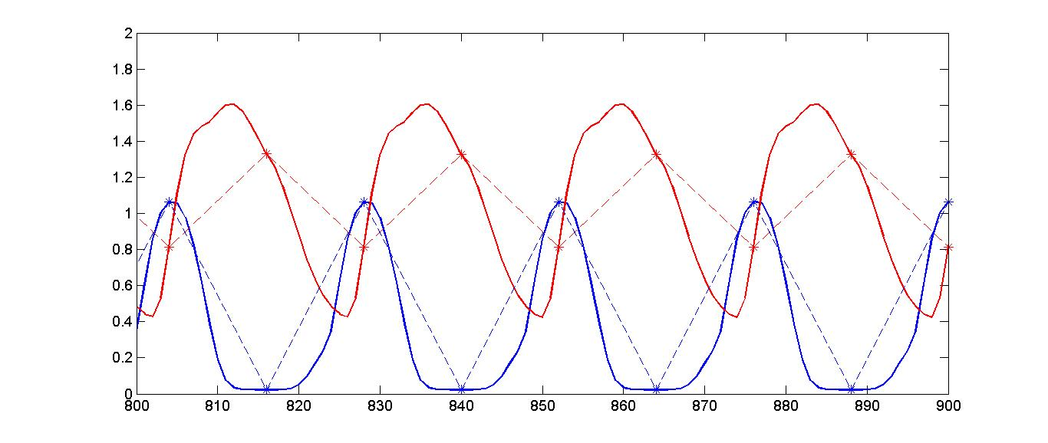

*ln* Abundance of adults

Time (days)

**Figure S13. Daily behavior of the model solution in Figure S12. Host and parasitoid populations are represented by blue and red solid curves, respectively. Stars represent population sizes on census days. Stars are connected by dashed lines in order to show population variation on census days more clearly.**

**The Effect of Variability in the Development Time of the *H*2 Stage**

We next examine the effect of variability in the *H*2stage on the dynamics, first examining a scenario like the unmanipulated controls. We will use the same set of parameter values as in Figure S12, except for the clumping parameter *k*. To better illustrate the effect of variability in *H*2, we set *k*=0.6625 so that the stabilizing effect of aggregated parasitoid attack is relatively weak. High variability in the *H*2 stage can be achieved by reducing the shape parameter $m_{H_{2}}$ of the gamma distribution, while changing the rate parameter $C_{H_{2}}$ to keep the same mean development time (Figure S14). Note that as the value of $m_{H_{2}}$ is decreased, the period 2 oscillations on census days are reduced and then eliminated. This occurs because variability in *H*2 development allows some hosts to escape parasitism when parasitoid densities are high, allowing another host cohort to arise between the period 2 peaks. Note that both host and parasitoid continue to regularly oscillate between census intervals, because of the pulsed addition of fresh beans to the microcosm.

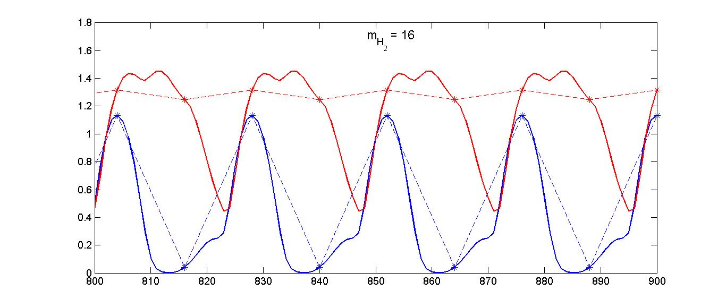

*ln* Abundance of adults

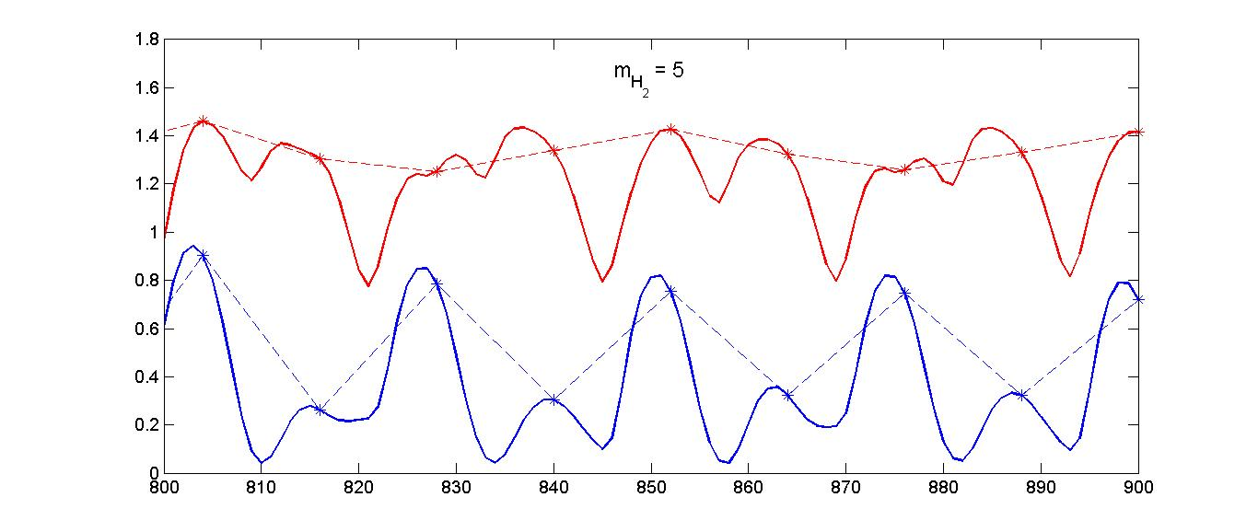

Time (days)

*ln* Abundance of adults

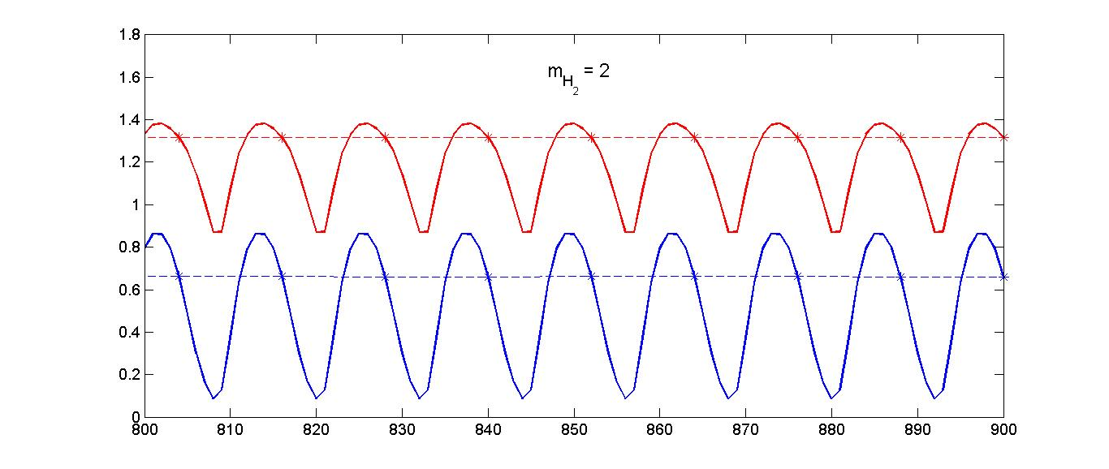

*ln* Abundance of adults

Time (days)

**Figure S14. Impact of the variability in host development time of the *H*2 stage: As the variability increases (i.e., decreasing $m_{H_{2}}$), more and more *H*2 hosts escape from parasitism and turn into adults in the bottom of the period 2 pattern and populations on census days oscillate less and less severely. The adult host and parasitoid populations are represented by blue and red solid curves, respectively. Stars represent population sizes on census days.**

We next examine the effect of developmental variability in a scenario closer to the experimental treatments. We simulated the model using the same set of parameter values as in Figure S12, but choosing $m_{H_{2}},C_{H_{2}}$ values so that the standard deviation of the *H*2 stage is about 1.45, with a mean of 2.6 days. These values are similar to those induced by the high variance treatment. We also used a fixed development time for the *H*1 stage of 12 days, to mimic the experimental manipulations. Figure S15 shows a simulation from this version of the model. We also used $m_{H_{2}},C_{H_{2}}$ values comparable to the normal variance treatment, to generate a standard deviation of about 0.4 with the same mean. In this case, the simulations were not persistent (the population fell below a cutoff value of 0.5). This suggests that variability in development time has a stabilizing effect on the model, enough to prevent extinction. To better observe this effect, we decreased the parasitoid clumping parameter *k* from the previous value of 0.9128 to 0.6128, which was sufficient for the normal variance treatment to persist. The solutions are shown in Figure S16. Note that the magnitude of the fluctuations on census days is smaller in the high variance treatment. An interesting feature of the normal variance simulation (and to a lesser extent the high variance one) is the appearance of longer period oscillations (4 or more census dates). This result could help explain why longer period oscillations were observed in the wavelet analysis for the normal variance treatment. It likely arises from shifts in the durations of the *H*1 and *H*2 stages as well as other model parameters, due to the experimental manipulations.

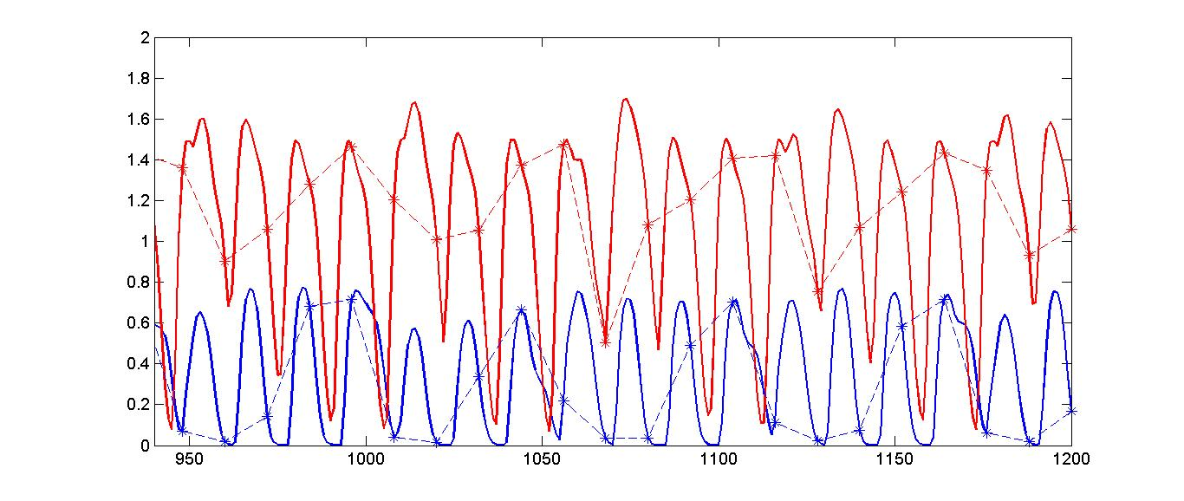

*ln* Abundance of adults

Time (days)

**Figure S15. Model simulation tailored to the high variance treatments. Adult host and parasitoid populations are represented by blue and red solid curves, respectively. Stars represent population sizes on census days. The simulation matching the normal variance treatment went extinct.**

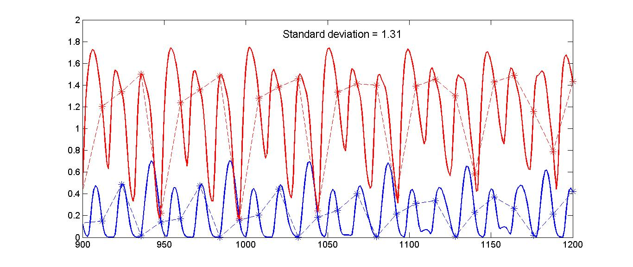

*ln* Abundance of adults

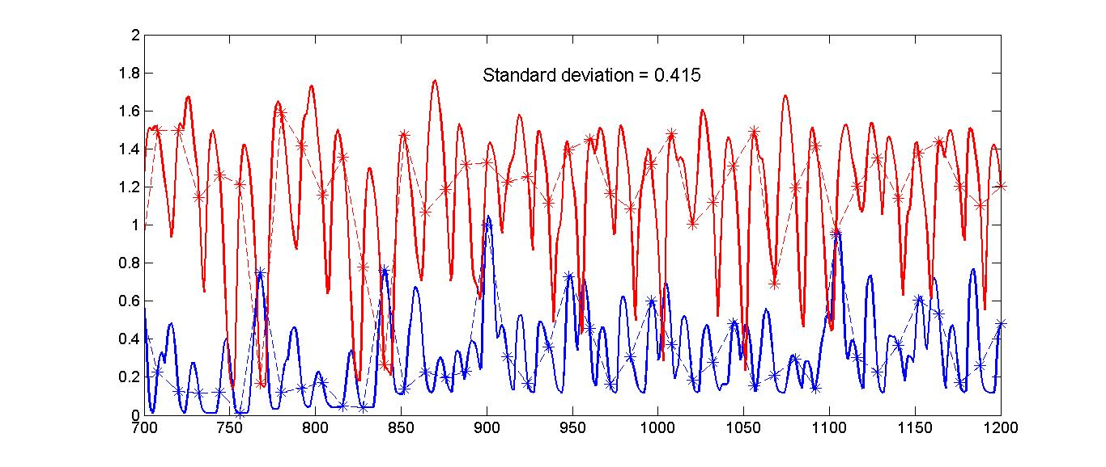

*ln* Abundance of adults

Time (days)

**Figure S16. Model simulations tailored to the high variance and normal variance treatments, but using a smaller value of *k* so that both are persistent*.* Adult host and parasitoid populations are represented by blue and red solid curves, respectively. Stars represent population sizes on census days.**

**The Bimodal Distribution in the High-Variance Treatment**

We utilized gamma distributions with different standard deviations to describe distributed times of *H2* hosts exposed to parasitoids in both high-variance and normal variance treatments. Our simulations show that high variability in *H*2 development times helps stabilizing host and parasitoid populations. Here, we tailor our model to fit more experiment manipulations, in particular, the bimodal distribution of *H*2 development times in the high-variance treatment.

In high-variance treatments a bimodal distribution was created by replacing one half of the beans that were oviposited on 9-12 days previously with beans with unparasitized hosts in the *H2* stage for 0-1 day, and the other one half by beans with aged 4-5 days *H2* hosts, while in normal treatments all infected beans were replaced by *H2* hosts with age 2-3 days. The maturation time of all those hosts should follow the same distribution as that of hosts in unmanipulated controls (without considering stochasticity of environments during the experimental processes), but the exposure time of hosts to parasitoids’ attack follows different distributions, which are essentially truncated distributions of host maturation in the *H2* stage. Therefore, for the simplicity of model simulations, we assumed that the manipulated cohort of hosts followed gamma distributed exposure times with the same scale parameter $C_{H_{2}}$ as that for the *H*2 hosts in the control situation, but with different shape parameter values. That is, in the high-variance treatment, we used two different shape parameter values for the manipulated halves of hosts to construct bimodally distributed exposure times. In the normal variance treatment we let the shape parameter take a value so that approximately the same mean exposure time as in the high-variance treatment can be constructed. However, the scale parameter $C_{H_{2}}$ always remains the same as that for *H2* host’s natural (control) maturation process. With these assumptions, our model can be easily tailored to describe the manipulations in both high-variance and normal variance treatments. We still use the same set of parameter values as in Figure S12, except for the shape parameter $m_{H_{2}}$. The mean exposure time for the high-variance and normal variance treatments is about 2.5-3 days. By assigning different values to $m_{H_{2}}$ (with a fixed development time 12 days for the *H1* stage), we simulated both high-variance and normal variance treatments with different mean exposure time between 2.5 and 3 days. Simulations show that there is no qualitative difference between cases with means within the above range. Simulated solutions in the cases of mean exposure time equal to about 2.5 and 3 days are shown in Figure S17. The population dynamics including the mean abundances and periods of oscillations is qualitatively similar to earlier results for single gamma distributions. Therefore, we conclude that it is the variability in the exposure time that leads to differences in the population dynamics. From the point of view of a qualitative mathematical model, and because gamma-distributed development times are most common (Xu et al. 2010), it is enough to use one gamma distribution in order to encapusulate the population dynamics.

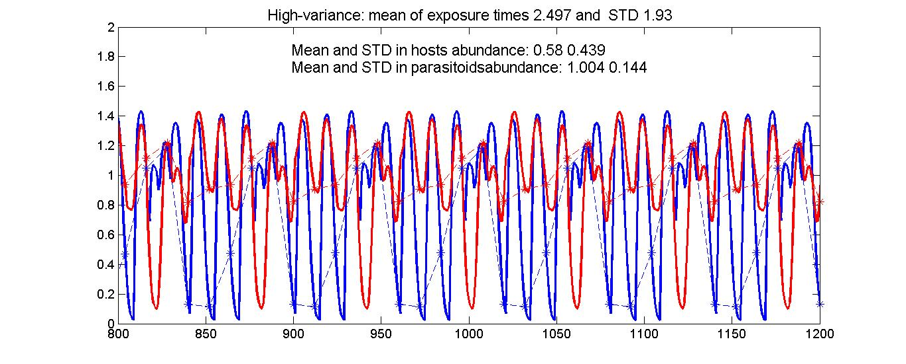

*ln* Abundance of adults

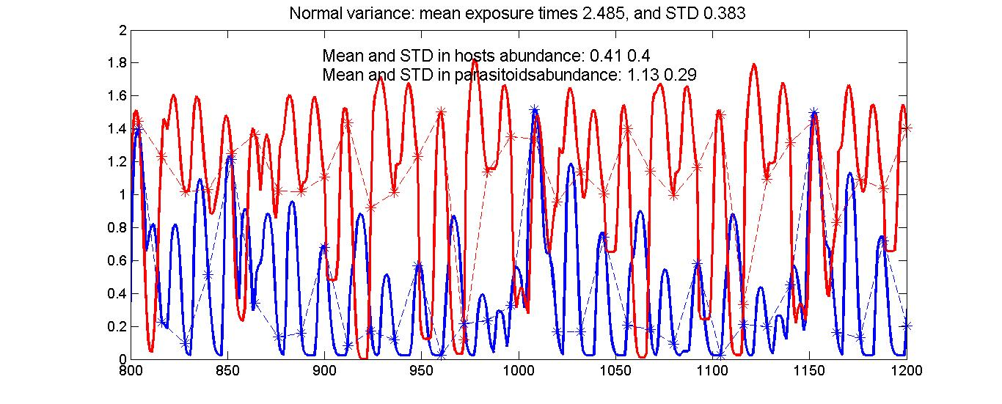

*ln* Abundance of adults

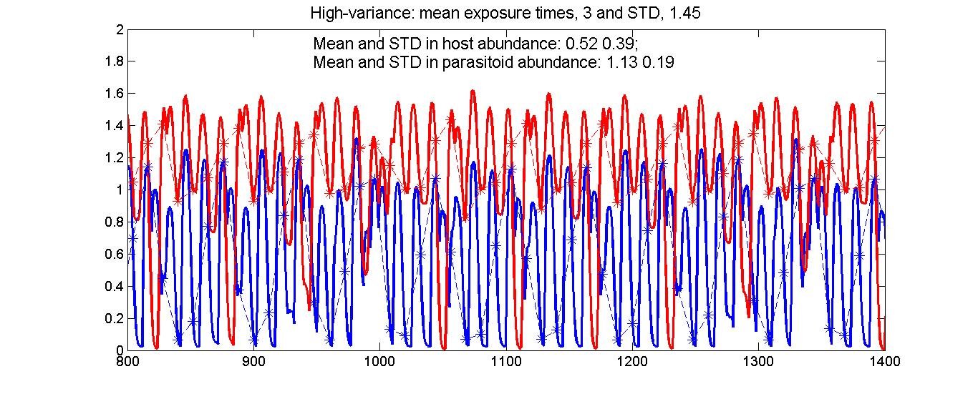

Time (days)

*ln* Abundance of adults

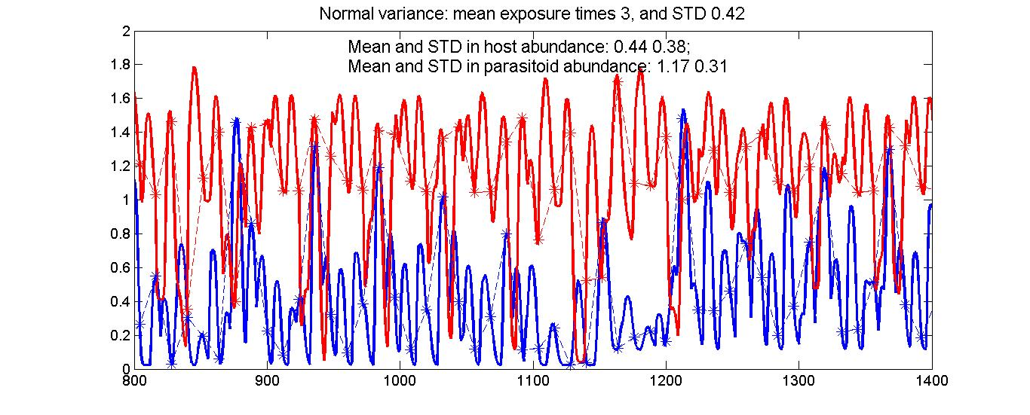

*ln* Abundance of adults

Time (days)

**Figure S17│Model simulations tailored to fit experimental manipulations in the high-variance and normal-variance treatments by considering distributions of exposure times as truncated distribution of maturation times. Parameter values are the same as in Figure S12, except for the shape parameter of gamma distributions.**

**Removing Variability in the Development Time of the *H*1 Stage**

The experimental manipulations of *H*2 stage has the byproduct of eliminating variability in the *H*1 stage, which could potentially influence the dynamics. We can examine this question using our model, modifying it to have a fixed delay $τ_{H_{1}}$ for the *H*1 stage equal to its mean development time. Using the same parameter values as in Figure S12, the model with a fixed delay for *H*1 has very similar dynamics to the model with developmental variability (period 2 oscillations). Therefore, we can see that there is no qualitative change in the population dynamics after eliminating variability in the *H*1 stage.

**Extinction in the Experimental Controls**

We can also use the model to help explain why the hosts (and then parasitoids) went extinct in 4 of 5 experimental controls. Using the same parameters as in Figure S12, and the fixed delay model from the previous section, we set $τ_{H_{1}}$ = 10.5 d to mimic the duration of *H*1 in this treatment. We observed that solutions of the model went extinct (the population fell below 0.5), with the hosts going first, similar to the microcosms. The extinction likely occurs because of increased synchrony between host and parasitoid development (because *H*1 is shorter), combined with a full *H*2 duration, leading to higher parasitoid densities that are able to extinguish the hosts.

**SUPPLEMENTAL REFERENCES**

Avidov Z., Applebaum S.W. & Berlinger M.J. (1965). Physiological aspects of host specificity in the Bruchidae: II - ovipositional preference and behaviour of *Callosobruchus chinensis* L. *Entomologia Experimentalis et Applicata*, 8, 96-106.

Cazelles B., Chavez M., Berteaux D., Menard F., Vik J.O., Jenouvrier S. & Stenseth N.C. (2008). Wavelet analysis of ecological time series. *Oecologia*, 156, 287-304.

Fujii K. (1983). Resource dependent stability in an experimental laboratory resource-herbivore-carnivore system. *Researches in Population Ecology*, 3 (Suppl.), 155-165.

Godfray H.C.J. & Hassell M.P. (1989). Discrete and continuous insect populations in tropical environments. *Journal of Animal Ecology*, 58, 153-174.

Guedes R.N.C., Guedes N.M.P. & Smith R.H. (2007). Larval competition within seeds: From the behaviour process to the ecological outcome in the seed beetle *Callosobruchus maculatus*. *Austral Ecol*, 32, 697-707.

Hassell M.P. (1980). Foraging strategies, population models and biological control: a case study. *Journal of Animal Ecology*, 49, 603-628.

Hassell M.P. (2000). *The spatial and temporal dynamics of host-parasitoid interactions*. Oxford University Press, Inc., New York.

Ji J., Choi W.I. & Ryoo M.I. (2004). Fitness and sex allocation of *Anisopteromalus calandrae* (Hymenoptera : Pteromalidae): relative fitness of large females and males in a multi-patch system. *Annals of the Entomological Society of America*, 97, 825-830.

Kendall B.E., Briggs C.J., Murdoch W.W., Turchin P., Ellner S.P. & Mccauley (1999). Why do populations cycle? A synthesis of statistical and mechanistic modeling approaches. *Ecology*, 80, 1789-1805.

MacDonald N. (1978). *Time lags in biological models*. Springer, Heidelberg, Germany.

Mbata G.N. (1992). Egg distribution on seeds by *Callosobruchus subinnotatus* (Pic) (Coleoptera, Bruchidae). *Journal of Stored Products Research*, 28, 301-305.

Messina F.J. & Renwick J.A.A. (1985). Mechanism of egg recognition by the cowpea weevil *Callosobruchus maculatus*. *Entomologia Experimentalis Et Applicata*, 37, 241-245.

Murdoch W.W., Nisbet R.M., Blythe S.P., Gurney W.S.C. & Reeve J.D. (1987). An invulnerable age class and stability in delay-differential parasitoid-host models. *American Naturalist*, 129, 263-282.

Stein M. (1987). Large sample properties of simulations using latin hypercube sampling. *Technometrics*, 29, 143-151.

Stillwell R.C. & Fox C.W. (2007). Environmental effects on sexual size dimorphism of a seed-feeding beetle. *Oecologia*, 153, 273-280.

Toquenaga Y. (1993). Contest and scramble competitions in *Callosobruchus maculatus* (Coleoptera, Bruchidae) .2. Larval competition and interference mechanisms. *Researches on Population Ecology*, 35, 57-68.

Toquenaga Y. & Fujii K. (1990). Contest and scramble competitions in *Callosobruchus maculatus* (Coleoptera, Bruchidae) .1. Larval competition curves and resource sharing patterns. *Researches on Population Ecology*, 33, 199-211.

Torrence C. & Compo G.P. (1998). A practical guide to wavelet analysis. *Bulletin of the American Meteorological Society*, 79, 61-78.

Tuda M. & Shimada M. (2005). Complexity, evolution, and persistence in host-parasitold experimental systems with *Callosobruchus* beetles as the host. *Advances in Ecological Research*, 37, 37-75.

Utida S. (1941). Studies on experimental population of the azuki bean weevil, *Callosobruchus chinensis* (L.). I. The effect of population density on the progeny population. *Memiors of the College of Agriculture, Kyoto Imperial University*, 48, 1-30.

Utida S. (1957). Cyclic fluctuations of population density intrinsic to the host-parasite system. *Ecology*, 38, 442-449.

Wearing H.J., Rohani P., Cameron T.C. & Sait S.M. (2004). The dynamical consequences of developmental variability and demographic stochasticity for host-parasitoid interactions. *American Naturalist*, 164, 543-558.

Welch B.L. (1951). On the comparison of several mean values: an alternate approach. *Biometrika*, 38, 330-336.

Xu D., Reeve J.D., Wang X. & Xiao M. (2010). Developmental variability and stability in continuous-time host–parasitoid models. *Theoretical Population Biology*, 78, 1-11.

Avidov Z., Applebaum S.W. & Berlinger M.J. (1965). Physiological aspects of host specificity in the Bruchidae: II - ovipositional preference and behaviour of *Callosobruchus chinensis* L. *Entomologia Experimentalis et Applicata*, 8, 96-106.

Cazelles B., Chavez M., Berteaux D., Menard F., Vik J.O., Jenouvrier S. & Stenseth N.C. (2008). Wavelet analysis of ecological time series. *Oecologia*, 156, 287-304.

Fujii K. (1983). Resource dependent stability in an experimental laboratory resource-herbivore-carnivore system. *Researches in Population Ecology*, 3 (Suppl.), 155-165.

Godfray H.C.J. & Hassell M.P. (1989). Discrete and continuous insect populations in tropical environments. *Journal of Animal Ecology*, 58, 153-174.

Guedes R.N.C., Guedes N.M.P. & Smith R.H. (2007). Larval competition within seeds: From the behaviour process to the ecological outcome in the seed beetle *Callosobruchus maculatus*. *Austral Ecol*, 32, 697-707.

Hassell M.P. (1980). Foraging strategies, population models and biological control: a case study. *Journal of Animal Ecology*, 49, 603-628.

Ji J., Choi W.I. & Ryoo M.I. (2004). Fitness and sex allocation of *Anisopteromalus calandrae* (Hymenoptera : Pteromalidae): relative fitness of large females and males in a multi-patch system. *Annals of the Entomological Society of America*, 97, 825-830.

Kendall B.E., Briggs C.J., Murdoch W.W., Turchin P., Ellner S.P. & Mccauley (1999). Why do populations cycle? A synthesis of statistical and mechanistic modeling approaches. *Ecology*, 80, 1789-1805.

MacDonald N. (1978). *Time lags in biological models*. Springer, Heidelberg, Germany.

Mbata G.N. (1992). Egg distribution on seeds by *Callosobruchus subinnotatus* (Pic) (Coleoptera, Bruchidae). *Journal of Stored Products Research*, 28, 301-305.

Messina F.J. & Renwick J.A.A. (1985). Mechanism of egg recognition by the cowpea weevil *Callosobruchus maculatus*. *Entomologia Experimentalis Et Applicata*, 37, 241-245.

Murdoch W.W., Nisbet R.M., Blythe S.P., Gurney W.S.C. & Reeve J.D. (1987). An invulnerable age class and stability in delay-differential parasitoid-host models. *American Naturalist*, 129, 263-282.

Stein M. (1987). Large sample properties of simulations using latin hypercube sampling. *Technometrics*, 29, 143-151.

Stillwell R.C. & Fox C.W. (2007). Environmental effects on sexual size dimorphism of a seed-feeding beetle. *Oecologia*, 153, 273-280.

Toquenaga Y. (1993). Contest and scramble competitions in *Callosobruchus maculatus* (Coleoptera, Bruchidae) .2. Larval competition and interference mechanisms. *Researches on Population Ecology*, 35, 57-68.

Toquenaga Y. & Fujii K. (1990). Contest and scramble competitions in *Callosobruchus maculatus* (Coleoptera, Bruchidae) .1. Larval competition curves and resource sharing patterns. *Researches on Population Ecology*, 33, 199-211.

Torrence C. & Compo G.P. (1998). A practical guide to wavelet analysis. *Bulletin of the American Meteorological Society*, 79, 61-78.

Tuda M. & Shimada M. (2005). Complexity, evolution, and persistence in host-parasitold experimental systems with *Callosobruchus* beetles as the host. *Advances in Ecological Research*, 37, 37-75.

Utida S. (1941). Studies on experimental population of the azuki bean weevil, *Callosobruchus chinensis* (L.). I. The effect of population density on the progeny population. *Memiors of the College of Agriculture, Kyoto Imperial University*, 48, 1-30.

Utida S. (1957). Cyclic fluctuations of population density intrinsic to the host-parasite system. *Ecology*, 38, 442-449.

Wearing H.J., Rohani P., Cameron T.C. & Sait S.M. (2004). The dynamical consequences of developmental variability and demographic stochasticity for host-parasitoid interactions. *American Naturalist*, 164, 543-558.

Welch B.L. (1951). On the comparison of several mean values: an alternate approach. *Biometrika*, 38, 330-336.

Xu D., Reeve J.D., Wang X. & Xiao M. (2010). Developmental variability and stability in continuous-time host–parasitoid models. *Theoretical Population Biology*, 78, 1-11.