Math 101 Getting Started in My Labs Plus
- Login to Salukinet, click on “My Courses” or “My Records”. Follow the Pearson MyLabsPlus. You will see something like the following on the screen. You will need to run the MyMathLab Browser Check. I would also highly recommend clicking on How to Enter in Answers using the MathXL Player.
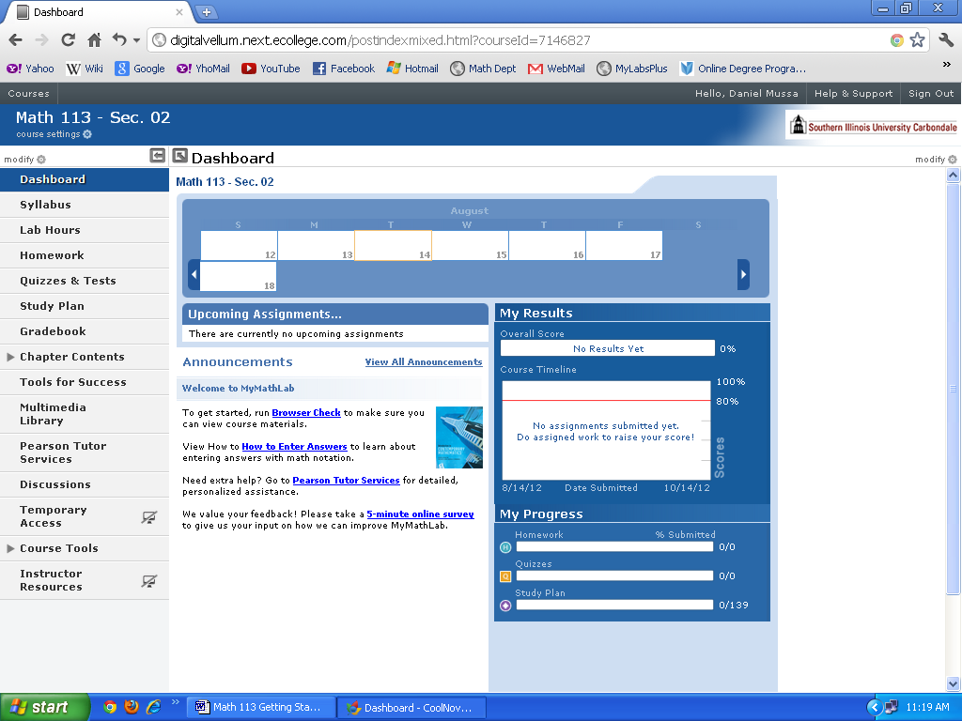
- Click on Homework on the left side of the screen. It may ask that you install a flash player, run a browser check, etc. if you didn’t run the Brower Check already.
- The next step is to register or purchase access. If you purchase the MATH 101 bundle at a local bookstore, the student access code comes packaged with the textbook. If you do not buy the textbook bundle, you may purchase just the code online, but the price is only a little less than the bundle.
- After registering the access code, you still will have to Accept the licensing agreement.
- You can now go in anytime you choose. To familiarize yourself with the MLP system, we recommend you take the course tour by clicking on the following link. http://youtu.be/NdQeeei7ynQ
- Submitting Homework/Taking a Quiz:
- You can enter and exit the homework sets as many times as you like. You don’t need to save as long as there are green checkmarks next to the questions (after you get a problem correct), it will automatically save.
- Try a problem at least once prior to using the help buttons and/or your class notes. Only input the final answer. Then click “CHECK.” You may answer (a given problem) incorrectly three times before you are shown the correct answer and the problem is counted wrong. This is considered one attempt. Click on Similar Exercise and you will get a new problem. In total you will get 3 attempts (3x3=9 tries) to answer a problem correctly.
- Be sure to keep a notebook with your homework neatly worked out. You may see some of these same problems on a test or quiz.
- Help buttons are located to the right. If you find yourself clicking on the help buttons for every problem, you do not know the material well enough and will need to spend extra time studying, attending open lab hours, coming to my office hours, etc.
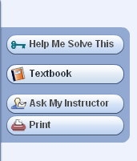

- Some answers may require math notation which can be found in the math palate to the left of each problem. Other symbols can be found by clicking on More.
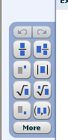
- Some quizzes may be timed. Unlike homework you cannot check your answers after each question. Once you are finished, click submit and your entire quiz will be saved. Grading is done immediately. Note: There are no help features available when taking a quiz.
- You may get two chances at a quiz (instructor will let you know). The system will automatically record the best of the two scores. You do not have to take the quiz a second time if you are happy with your first result.

If you would like to print sections of the book, watch a video, etc., click on the Chapter tabs on the bottom left side of the screen from the My Labs Plus main page.
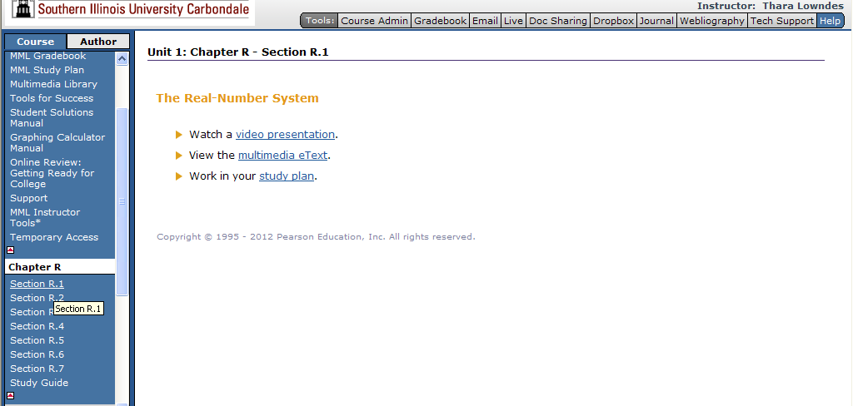

MLP provides plenty of learning resources but some of you may prefer one-on-one tutoring. In Summer 2013, Open labs in Morris Library Room 174 are scheduled for:
- Sunday 6:00 - 9:00 p.m.
- Monday 1:30 - 4:00 p.m.
- Tuesday 2:00 - 5:00 p.m.
- Wednesday 1:00 - 4:00 p.m.
- Thursday 2:00 - 5:00 p.m.

